ACCEPTANCE AND ENDORSEMENT CERTIFICATION

for the

(Fire Department Name Here)
Standard Operating Guidelines Manual

We the undersigned hereby accept and endorse this operations and procedure manual on behalf of (Fire Department Name Here), (County Name), North Carolina.

This manual in its entirety shall be utilized by the officers and members of the (Fire Department Name Here) until such time as it is replaced, revised, or withdrawn.

Updates and revisions are also hereby adopted upon signature of the company’s Safety Officer, Chief, and one member of the Board of Directors.

The following signatures signify adoption of this manual through majority vote at a duly authorized meeting held by referenced organization.

Fire Chief: | (signed) |  | Date:
President of Board of Directors |  | (signed)

This is a Controlled Document. If you have a copy and the words “Controlled Document” are not in red, you have an uncontrolled document and should not rely on it to have the latest information
Standard Operating Guidelines Index
Preface 3
Standard Operations 4
General 4
Incident Command System 4
1.0 Responding to an Alarm 6
2.0 Exiting the Station 8
3.0 En Route Activities 9
4.0 First Due Fire Activities 11
5.0 Ventilation 13
6.0 Laddering 15
7.0 Fire Rescue 16
8.0 Exposure Protection 18
9.0 At the Water Source 19
10.0 Hose Lay Operations 20
11.0 Extinguishment and Control 22
12.0 Rest and Recovery 24
13.0 Overhaul Operations 25
14.0 Salvage 27
15.0 Investigations and Reports 28
16.0 Medical and Emergency Care 29
17.0 Storm Stand-by 30
18.0 Basement Floodings 31
19.0 Radio and Communications 32
20.0 Fire Investigation Guidelines 33
21.0 High Rise Building Procedures 35
22.0 Elevator Procedures 36
23.0 Control of Hazardous Area 38
24.0 Lost or Trapped Firefighters 41
25.0 Bomb Procedures 43
26.0 Helicopter Safety Guidelines 44
27.0 First Responder Guidelines – Medical Protocols 47
28.0 Infection (Exposure) Control 49
29.0 Standard Call Procedures 51
30.0 Automated External Defibrillation (AED) Machine 53
31.0 Glucose Administration 54
32.0 Epinephrine Administration 55
33.0 Supplemental Oxygen Administration 56
34.0 Guidelines for S.R.S. Air Bags in Automobiles 57
35.0 Vehicle Accidents: Extrication & Disentanglement 59
36.0 Standard Operating Guidelines for Life Safety Ropes 60
37.0 Standard Operating Guidelines for a Search 62
38.0 Glossary of Terms 63
Attachments 65
PREFACE

The development and preparation of a standard operation guidelines manual (SOG) is not a one time endeavor. It requires consistent and periodic review for assurance of compliance by the department members, applicability to the apparatus and equipment utilized, insurance against wrongful damage claims, and most importantly, safety of department members and the general public.

Consequently, each member has a duty and obligation to comply with the requirements of the procedures. The members also have a duty to each other to monitor team compliance for the safety of the crew or operating unit at an incident. Any infractions or inapplicability of the operating guidelines must be reported to the officer-in-charge and a report submitted to the SOG Committee.

To accomplish the tasks of fire fighting, rescue and first responder, the department must exemplify all activities and operations associated with this purpose. This includes both on-scene activities as well as response and clean-up operations.

These activities are:
- Rescue trapped victims.
- Protect uninvolved structures and property.
- Confine the fire area to prevent spread.
- Extinguish the existing fire.
- Overhaul and salvage remaining property.

However, in order to accomplish these activities the members must conduct the required tasks in a safe fashion to prevent further damage or harm to himself or his fellow members. The members must also realize that the public served looks upon them as professionals with sincere interest in protecting and preserving other’s possessions and family.

Therefore, compliance with these procedures shall be mandatory under all fireground, drill, rescue, or mutual aid activities of this department. Failure to abide will subject the violator to immediate removal from the working scene as well as appropriate disciplinary action in accordance with the department’s Rules and Regulations.

Exceptions to any of these procedures must be approved by an elected officer of the Department or the Safety Officer.
STANDARD OPERATIONS

GENERAL

There exist certain standard fire rescue operations that must be considered for virtually every alarm location. Although all operations may not be required on each alarm, they must be considered.

These operations require a clear understanding of work, functions, tools, responsibilities, duties and commands.

Since errors in judgment, decisions, and work procedures could cause catastrophic results, only those members who have been provided drill opportunities in the areas noted should be allowed to perform the specific task.

Company officers must assure full utilization of the buddy system during activities, as well as consistent re-evaluation of performance and fire status.

Should the situation be such that adherence to any one or multiple standard operating procedures may compromise member safety or desired outcome, the officer-in-charge may modify the procedure or procedures to assure member safety and best practical outcome.

INCIDENT COMMAND SYSTEM

(Fire Department Name Here) will use the Incident Command System (ICS) for all operations. The depth of ICS will be determined by the incident. All (Fire Department Name Here) personnel should have a working knowledge of the ICS structure.

Activation:
The first member arriving at the scene of an incident will assume the responsibilities of the Incident Commander. The Incident Commander will remain in command until relieved by a higher ranking officer, a member with higher training, or until the incident is terminated.

Command:
- Command will be established by contacting Dispatch. An initial scene survey should be reported, additional manpower and resources requested, and instructions given for the response of additional rescue vehicles and personnel (staging, parking, direction, distance).
- If responding to assist another agency, contact that agency’s Incident Commander and ask how you can assist them and where to stage.
- Information such as staging, direction of approach, special hazards and POV response should be communicated. The majority of the membership will have pagers only, so any communications for their response must be on the main communication channel.
- The Incident Commander will advise Dispatch when the incident is terminated.

Responsibilities of Command:
- Overall responsibility for the incident
- Ensure the safety of all personnel
- Set up a Command Post
- Develop a rescue plan
- Assign personnel as required
- Develop a backup plan
- Communications with other agencies
- Accountability of all personnel
- Preparation for the Incident Report

Transfer of Command:
- Transfer must be in person
- To a higher ranking officer or member with higher training
- To a member with a specialization in the type of incident

1.0 RESPONDING TO AN ALARM

Members’ response to an alarm must be performed as safe and as professional as the activities themselves. A safe arrival at the station or alarm in a clear frame of mind to perform activities expected is paramount to overall response effectiveness.

1.1 Initial Page

a. Upon receiving a page tone you are to await the dispatcher’s verbal message for alarm location, type, or special announcement.

b. Should you be “involved” upon hearing a tone which requires a response, terminate activities as best and safe as possible should you intend to respond.

c. Should you be sufficiently delayed, you should report, routine traffic, to the station as soon as possible, provided that your response is timely enough to assist in either the alarm call or wrap-up upon return of the apparatus to the station.

1.2 Leaving Your Home

a. Prior to leaving your residence or place of pager activation be sure all potential hazards are terminated, such as stoves off, water shut down, etc.

b. Use extreme caution when exiting your drive or pulling away from the curb, being sure the traffic lanes are clear for you to do so. Under no circumstances are you to force your entry into the traffic lane.

c. Be sure you have picked up your wallet and secured the exiting doorway behind you.

d. Dress appropriately for weather conditions.

1.3 Enroute to the Station or Scene

a. Observation of local traffic regulations and signaling devices is to be observed at all times unless traffic yields to your vehicle.

b. Seatbelts must be worn in accordance with motor vehicle regulations.

c. The use of red lights must be in accordance with permitting regulations.

d. You are responsible for all traffic violations regardless of the severity of the alarm being responded to.

e. Driver/Operators are to respond to the station for an apparatus unless all the necessary vehicles are already en route to the scene.

f. If you are close to the station and you are responding to pick up equipment check in as signal 12. This will mean you’re enroute to pick up equipment.

1.4 At the Station

Extreme caution must be used upon approaching the station since conflict may occur with exiting apparatus.

Under no circumstances are you to cross the entrance/exit drives of the station without yielding to emergency apparatus, unless visual contact and directions are given otherwise by the seated apparatus driver.

Parking at the station must be such that no compromise is made to station parking spaces or driveways. You are required to properly secure your vehicle including the turning off of red lights, to assure of safety and security while away from the station.

Under no circumstances are you to leave your vehicle running or parked in non-designated parking areas.

Should you have responded with a family member in the vehicle who will not be taking the vehicle, they are to proceed to the meeting area of the station and await your return.

Due to insurance regulations as well as safety of members on scene, non-family members are to either secure return transportation or remain in the vehicle, unless directed otherwise by a department officer.
2.0 EXITING THE STATION

Exiting the station is a firm commitment to actively perform at the scene. This exiting shall be accomplished with all the necessary protective clothing and assurance that your vehicle is safely secured at the station.

2.1 Boarding the Apparatus

a. Boarding the apparatus should not be performed unless the appropriate PPE gear is donned or on board the apparatus. This includes the appropriate fire or rescue equipment need.

b. Under no circumstances is apparatus to be boarded under motion, or in excess of seating capacity. Tail boarding is strictly prohibited.

c. Probationary members and juniors are to board only under direct orders from an officer or senior member, and only when all other available members are properly positioned.

d. Under adverse weather conditions it is conceivable that one may fall in attempting to board.

e. Seatbelts must be worn at all times by all occupants of the apparatus.

2.2 Remaining Behind

a. Any member remaining behind during an alarm is to monitor the radio for necessary communications as well as answer any telephone calls for members.

b. Press inquiries or scene reports are to be deferred to the appropriate officer at the scene.

c. It is also the responsibility of the member remaining behind to periodically check on any family members that may be waiting in the meeting area.

3.0 ENROUTE ACTIVITIES

A. Observation of local traffic regulations and signaling devices is to be observed at all times unless traffic yields to the apparatus.

B. Drivers are to determine equipment assignments and priority to assure that when dismounting appropriate equipment requirements are satisfied.

3.1 Initial Approach

a. The last 500 feet of approach must be carefully examined by both the driver and members for people, vehicles, and other possible helpful or impeding items.

3.2 Positioning the Apparatus

a. Apparatus shall be positioned such that additional responding units can be properly positioned for effective operations, as well as to allow for efficient hose lays.

b. Under no circumstances are vehicles to be located within the collapse zone of any involved or potentially involved structure.

c. No vehicle, except for an assigned Engine or Tanker, is to be located within 25 feet of any hydrant, hose, standpipe, or sprinkler valve connection.

d. Dead end streets or alleys are to be backed in when time allows: or if not feasible, clear back-out paths must be maintained.

e. Engines are to be positioned for single hose lays without the need for additional sections on pre-connects when possible.

f. EMS apparatus, rescue vehicles, special service vehicles, and unassigned apparatus are to be located at an initial Staging Area unless otherwise directed by the officer-in-charge. This Staging Area is to be located so as not to interfere with any vehicles entering or exiting the scene, hose lays, or “lock-in” due to inadequate exiting paths without the need to cross hose lays.

g. The Staging Officer shall be responsible for proper staging and discharge of any staged vehicle or personnel as directed by the Incident Commander.

3.3 Initial Report

a. The initial report is to be made by the first unit on scene to DISPATCH after the apparatus is properly positioned and an initial size-up has been made.

b. The initial report is to be made as brief yet clear as possible. Unknown facts are not to be guessed at, since these facts can only be obtained through close examination or input from the property owner or neighboring residents.

c. The initial report should include:
1. Unit in command (designated by Command), i.e., “Engine 1” to DISPATCH, this will be Engine 1 Command”. In case of multiple calls Command will be designated by location.
2. Smoke or fire visible, possible exposures
3. Victims or possibly trapped occupants
4. Request additional resource if necessary.
5. Summary of actions taken
6. Other pertinent information
7. Request a Fireground channel

d. If immediate action is to occur, the incident commander must indicate such and, since operational commitments will be made by the crew, command should be transferred to the next responding officer to arrive.

3.4 Dispatching the Crew

a. The officer-in-charge is responsible for assigning the crew and providing orders for initial activities.

b. It is also this officer’s responsibility to assure that appropriate initial actions are deployed, as well as positioning the apparatus needed.

c. The officer-in-charge is also to provide a secondary report to DISPATCH to advise all additional responding units of proper response and/or cancellation to include automatic aid companies.

d. Under no circumstances are crews to be committed without specific orders, nor are excess crews or personnel to be released from the scene. At no time shall any individual conduct any activities unless instructed to do so by an officer (no freelancing will be tolerated).
4.0 FIRST DUE FIRE ACTIVITIES

First due activities are crucial to a successful outcome. If initial size-up is lacking in either examining exposures or observing present smoke or fire status, additional responding units may hamper in providing the necessary services.

First due activities can mean the difference between controlling the situation or reacting to it. As such, the officer-in-charge must have a clear understanding of both the location type and construction type to assure of safe and effective protocols under the alarm condition observed on the initial size-up.

4.1 Scene Size-Up

a. Upon approach and arrival an initial exterior exam of no less than three exposures will occur. Signs of smoke, flame, vapors, or other disturbances will be immediately reported to DISPATCH.

b. If nothing is showing and an investigation is to occur, at least one crew member in full turnout gear with handlight and an axe is to accompany the officer (also in full turnout gear).

c. Should the involved structure be attached to other buildings, these attached buildings will be considered potential exposure fire hazards until interior examination reveals otherwise.

d. Command will be established by road name and confirmed with DISPATCH.

e. A staging area will be established and report to DISPATCH for relay to additional responding apparatus and EMS units.

f. The initial size-up will attempt to determine potential fire spread and fuel sources prior to committing personnel. This will prevent the selection of inadequate hose and nozzle sizes to deal with any escalation.

g. It is imperative to evaluate and determine potential or real victims that have not exited the structure, and request additional support as needed to handle this aspect.

h. Ancillary items, such as charged electrical lines, propane tanks, and weather conditions must also be evaluated during initial size-up. This should also be included in the secondary report to DISPATCH.

4.2 External Activities

a. Efforts must be made to perform a complete exterior examination of all vertical sides as well as clear visual examination of signs of compromise of the roof and flooring.

b. Indications of trapped victims or concealed involvement must be immediately reported to an officer and plans made for further interior examination.

c. Under no circumstances are fire fighters to enter a potentially involved or adjacent structure without appropriate protective clothing, SCBA on and breathing, with at least one crew member carrying an entry tool.

d. All members located on the fireground must be wearing full turnout gear.

e. Exposure buildings or structures must be laddered or planned for should flyover embers cause roof fires.

f. Radiant and convection heat may cause exposed curtains, blinds, or other low ignition fuel sources to erupt. As such, this consideration is crucial in preventing exposure fire losses.

4.3 Internal Activities

a. Whether approach and size-up indicate fire activity or not does not exempt the demand for internal examination.

b. Should evidence of trapped, or potentially trapped victims, be found, immediate rescue attempts should be made, provided fire fighter safety is not compromised.

5.0 VENTILATION

Ventilation is critical in active response for several reasons. Some of these reasons are:
- Removing toxic gases
- Clearing the atmosphere for vision
- Provide a survivable atmosphere for trapped victims
- Prevent fire spread through heated gases
- Prevention of backdraft or flashover

This last aspect is tricky, since improper ventilation will result in causing that which is trying to be avoided.

5.1 Warnings

a. Use extreme caution when ventilating an involved structure that presents signs of “breathing,” or exterior examination shows signs of structure bulging, blackened glass, or “puffing smoke;” all are signs of a possible backdraft condition.

b. Ventilation is not to occur until a charged line is available for initial flame knockdown or ventilation control.

5.2 Exposure Control

a. Attached and adjacent buildings must be carefully observed for both flashover burning and signs of radiant or conductive fire potential.

b. Under conditions that exhibit flashback or backdraft potential, ventilation must proceed with extreme caution.

5.3 Exterior Ventilation

a. Under no circumstances is roof ventilation to occur without at least one auxiliary exit planned, and only when roof indications are such that integrity and safety can be assured.

b. Ventilation should be initiated through exterior activities if at all possible. Windows, doorways, skylights, or any other exterior access opening must be totally cleared of structural members, screens, blinds, curtains, glass and curtains.

c. If no exterior openings are available, members shall use appropriate ventilation techniques.

d. Ventilation crews shall consist of fire fighters working in pairs with the following minimum tools: axe, handlight, hoseline and safety rope.

5.4 Interior Ventilation

a. Interior ventilation will occur in conjunction with primary search activities.

b. A back-up crew with a charged hoseline will be available for safety at all times.

c. Interior ventilation must consider exterior exposure rooms as well as interior “blind” rooms, closets, attics, ante rooms, or other “confined spaces.”

d. As with exterior ventilation, windows, doors, or other exterior access openings must be completely cleared of framework, blinds, etc.

5.5 Safety

a. Ventilation safety is paramount for fire fighter safety, since improper ventilation can aggravate the fire condition.

b. Ventilation must initially occur on the lee side, working from structure top to bottom, including basement, crawl space, or below grade floor.

c. During ventilation all personnel must be aware of falling debris and venting gases. As such, ventilation must occur under full dress conditions – turnout clothing and air packs.

d. Ventilation crews are not to be used as interior attack crews, since conflict over priority activities may occur – Do I vent or fight?

e. Ventilation crews operating on the roof are required to attach a safety line and have a charged hoseline.

6.0 LADDERING

The importance of laddering a fire structure cannot be emphasized enough. Roof and upper floor access, including any attic or “widows watch” can be a haven for rising gases of both a toxic and fire nature. Heat build-up alone can cause secondary fires or flaring, jeopardizing lower floor and ground activities.

6.1 Fire Structure

a. The fire structure is to be laddered at two locations, preferably at opposite ends. This laddering is not to be placed in such a fashion as to hamper or prevent the use of exterior access ways.
b. Should multiple roof landings exist, each landing is to be laddered as best practical in to assure access to all roofs. Caution must be exercised when laddering is necessary over or adjacent to the involved portion of the structure.
c. Plans must be made for interior laddering in case of stairway failure or the need for interior attic access.
d. All ladders used must be fire service rated ladders.
e. When dismounting a roof ladder “sounding” for the roof surface must be performed to assure of soundness and surface safety. Roof mounted ladders occasionally go over parapets located several feet above the true roof surface.
f. Make sure proper techniques are used while raising and lowering equipment on ladders.

6.2 Safety

a. Ladder safety must be practices at all times. This includes proper raising and lowering, angling, leg locks, hose lay tie-ins, and proper ladder loading of manpower and equipment.
b. Always look for overhead power lines and other obstructions before erecting any ladder.
c. A fire fighter is to remain at all ladder bases in full turnout gear to stabilize the ladder and be ready to assist should trouble arise.
d. The first up fire fighter is to remain at the ladder top and succeeding fire fighters are to remain to assist those still climbing.
e. During poor light conditions every effort must be made to light ladders, either with the use of apparatus lights, ground lights or hand lights.

f. If possible, both the base and top of the ladder should be anchored to the structure or other fixed point to prevent slipping or falling.
7.0 FIRE RESCUE

Rescue is the search and recovery of trapped or potentially trapped fire victims. These victims may be ambulatory, confined, or lifeless, and both physical and emotional status will be subject to compromise. It is further possible that these victims may be “pinned” as a result of structure failure. Remember, however, that for a fire fighter no victim is “dead,” and safe recovery must proceed if at all possible.

7.1 Rescue Considerations

a. Immediate rescue is the only justification for a delay in getting water on a fire. These justifications would include:
    - People who are on fire;
    - People who are trapped in the involved building;
    - People who are preparing to jump from upper stories.

7.2 Search and Rescue Procedures

a. Water is essential for search and rescue because it
- Separates fire from persons trapped;
- Controls interior stairs and corridors for evacuating occupants by advance firefighters;
- People who are preparing to jump from upper stories.
b. Be systematic, be thorough in your search.
c. Mark searched areas and rooms with stop-lock devices hung on all doors.
d. Search areas closest to the fire, heat and smoke first. Wear breathing apparatus and carry handlights, extra stop-lock devices and forcible entry tools.
e. Ask police and EMS personnel to evacuate areas not immediately endangered by fire.
f. Hallways and stairwells must be protected by hose streams. Insure that all doors are closed to slow the speed of fire into hallways and stairwells.

7.3 Warnings

a. Should the structure fire show signs of flashback, backdraft, or potential structure collapse no rescue effort is to be made until cleared to do so by the officer in charge.
b. Rescue is not to proceed in any fully involved or declared unsafe structure. This includes unstable vehicles, aircraft, boats or trailers.

7.4 Recovery

a. Rescue recovery is to take place each time a victim is located, with continued search occurring once the victim is either released to a second crew or brought to the structure exterior.
b. If return to the initial entry point becomes compromised or questionable, every effort must be made to reach an exterior opening capable of victim recovery.
c. Under no circumstances is a victim to be left unattended.
d. If fire fighter safety is compromised due to the hardship or danger presented during recovery, recovery efforts are to be transferred to additional personnel or terminated.
e. Recovery of pets is not to occur unless specifically ordered by the officer-in-charge.
f. Search crews must always utilize the buddy system (i.e. 2 in, 2 out)

7.5 Triage

a. Triage activities may have to be carried out during recovery operations if multiple victims are located together, or exit activities uncover other victims.
b. Medical triage or aid is not to be conducted or evaluated during recovery by fire fighters, including those qualified as EMT or paramedic. This activity is the sole responsibility of the medical service units on scene.

7.6 Safety

a. Rescue safety is to consider the fire fighter first, since injury to the same will prevent further rescue activities from proceeding rapidly.
b. Structure integrity and safety, either in total concept or by room or floor must be assured prior to initiating rescue activities.
c. Laddering of a minimum of one location on each floor must be available either before rescue begins or as soon as practical thereafter.
d. Ventilation should occur in conjunction with rescue activities provided victim recovery is not compromised.
8.0 EXPOSURE PROTECTION

Exposure protection is necessary in order to prevent uninvolved fuel sources from becoming fire involved. This includes but is not limited to attached structures, adjacent structures, and peripheral fuel sources, such as rooms, furniture, drapes, or other combustible materials.

8.1 Involved Structure

a. The involved structure is to be examined carefully for any signs of uninvolved fuel sources, as well as possible concealed space fire potentials.
b. Areas of uninvolvement or materials not consumed in the burn area are to be treated as exposure fire potential and be protected accordingly.

8.2 Attached Structures

a. Attached structures or ante rooms must be protected from involvement in the burn by using exposure protection control methods.
b. Doors and windows are to remain shut to prevent fire extension, yet caution must be exercised to prevent potential radiant or convection fire from occurring. This is to be controlled through limited application of water directly on the adjacent exposures.
c. Attics, cock lofts, and basements of attached structures must be examined for fire extension and the need for exposure protection since most often these are “shared” areas.

8.3 Adjacent Structures

a. Adjacent structure exposure protection is accomplished with proper application of water on the structure and/or foam.
b. Roof areas of adjacent structures must be constantly monitored for wind carried embers or fire debris. As such, laddering of adjacent buildings is to be conducted provided adequate manpower and ladders are available.

8.4 Apparatus Placement

a. Placement of apparatus for exposure protection must not be done at the compromise of fire fighting placement. However it is possible to position apparatus to afford adequate fire fighting hose lays and still conduct reasonable exposure control.
b. The exchange of fire fighting activities with exposure control activities must be conservative and is to be carried out under direct orders of the IC or line officer.

8.5 Exposure Warning Signs

a. Potential exposure fire eruption signs include, but are not limited to, the following:
Paint blistering,
Vapor releases,
Discoloration, and
Cracking glass
Should any of these signs become evident, manpower and resources must be turned to the structure for immediate protection, and the structure treated as a secondary fire scene.

9.0 AT THE WATER SOURCE

Water source activities are very important to the outcome of an incident. Water supply to the scene of an incident is crucial to the safety of the attack teams to maintain their water supply. This activity will require automatic aid companies to assist with filling and tankers to haul waters to the scene.

9.1 Dry Hydrant / Water Points

a. First arriving tanker will set up drop tank, fill drop tank and then proceed to water supply point.
b. The officer-in-charge will determine where to stage incoming automatic aid units including where to set up the water supply point.
c. Automatic Aid pumper will respond to dry hydrant/water points.

9.2 Safety

a. Driving to a response and between fill points and drop points should be done in the safest manner possible. All safety rules and motor vehicle laws shall be followed, including the use of emergency warning lights.
b. The water supply officer shall monitor the water supply point for ground stability.

10.0 HOSE LAY OPERATIONS

Hose lay operations cannot be specified to any detail since location, fire involvement, apparatus responding, and manpower will play critical roles. However, general hose lay principles can be adhered to under any situation.

10.1 Sizing and Flow

a. The pulled hose shall be specified by the pump operator or officer-in-charge at the fire scene, and will only be pulled under direct orders.
b. In general, hose pulls shall be as follows:
1. Leaves, brush or other small confined exterior container – booster, 1¾ or 1½ inch, or forestry
2. Dumpster, car, shed, trailer, or single residential room – 1¾ or 1½ inch line
3. Multiple room, lumber pile, large shed, or detached garage – 1½ up to 2½ inch line
4. Involved structure, large shed, industrial, or commercial facility – minimum of two 1½ or 1¾ inch lines, additional as needed
c. The flow in the hose shall not exceed capacity of the hose, pump, or the crew manning it. This is for both rate (gpm) and pressure (psi). As a general guide, nozzle flow must be adequate for intended use (i.e., straight stream, fog, or broken stream). A rule of thumb would be: Straightbore – between 50-80 psi, all other lines start with 110 psi and adjust according to the line officer.
d. Master stream hoses and feed lines (2½ inch and up) shall be charged and pressurized as directed by the officer-in-charge or line officer.

10.2 Charging the Lines

a. Hose lays are not to be charged until ordered to do so by the officer-in-charge or line officer.

10.3 Manpower Requirements

a. Manpower requirements for hose lays shall not be less than the minimum specified as follows:
Booster – 1 fire fighter;
1½ inch to 2 inch – 3 fire fighters;
2½ inch or 3 inch – 4 fire fighters.
(This includes line officer.)

b. It is not necessary to man feeder hose lays. However, periodic examination of the line is encouraged to assure of holdings of the fittings and for general line integrity.
c. Under ladder hose lay conditions safety must be considered when manning the lines. Therefore, it is permissible to reduce the number of fire fighters manning the line provided adequate tie-off of the nozzle is performed.

10.4 Routing the Lines

a. The routing of hose lines is not to be a no-thought consideration and must be preplanned to assure of sufficient flexibility for extension or withdrawal.
b. Pulling adequate hose sections must be assured for full extension into or around the fire involved area.
c. Hose lays shall be routed such that the potential snagging of the hose body or couplings is minimized. Care must be used when routing hoses as follows:
Over or under fences,
Through self-closing doors,
Across bridges or ground depressions,
Through windows,
Around corners, or
Up and down stairs or ramps.
d. All kinks, sharp bends, angles, and “switch-backs” must be “smoothed-out” as best practical without compromising either hose extension or withdrawal requirements.
e. Ground lays must consider such objects as trees, shrubs, lawn sprinkler spikes, undisclosed toys or garden equipment.
f. Care must also be considered when laying hose on abrasive surfaces, such as pavement, concrete, stone and gravel.
g. Hose lays are to be run as straight and direct as possible for feeder lines, keeping as such roadway surface as clear as possible for emergency vehicle traffic.

10.5 Safety

a. Hose line safety is very important both to the line fire fighters and other personnel on the fire scene. The uncontrolled whipping has been known to damage and harm equipment and personnel. While some of this is the result of hose line failure, other causes include:
    - Inappropriate manning,
    - Excessive line pressure,
    - Sudden nozzle adjustments, and
    - Sharp hose line turns.
b. When operating a hose line, face shields must be fully lowered and gloves worn at all times. Wrapping of the hose line around or through legs is prohibited, as well as shouldering of a charged line, whether there is water flowing or not.
c. If “riding the hose” is required, such as when using a 2½ inch line for a monitor, hands are to be placed as close to the crotch as possible. Hand placement, at all times, must be adequate for hose control.
d. Full turnout gear is required for any hose line operation on the fire ground, and in addition, SCBA must be utilized for interior attacks or any potentially hazardous environment.

11.0 EXTINGUISHMENT AND CONTROL

Fire extinguishment and control is the climax of any fire operation regardless of the size of the area of involvement. Therefore, it is imperative to reach this point. It may be that in order to be successful in extinguishment; the best the responding units can do is controlled burning. This aspect of fire control cannot be overlooked, especially when dealing with field, timber, or lumber yard fires. All avenues of fire extension should be investigated at this time for proper containment.

11.1 Exterior Attack

a. Exterior activities must be watchful of both falling debris and interior activities.
b. Should an interior crew be approaching or within an exterior attack area, exterior crews must shut down water streams to assure the safety of interior crew operations.
c. All exterior activities are to be conducted in full turnout gear with air packs on and charged due to smoke or vapor conditions. Faceshields are to be in the full down position unless otherwise instructed by line officer.
d. When conducting exterior attack, examination of roof and 360 degree structure integrity must be performed to prevent collapse on working crews.

11.2 Interior Attack

a. Interior fire attack operations are not to be performed within unsafe structure or “surround and drown” designated structures.
b. Interior fire attack is not to be performed in rooms being fought with exterior lines.
c. When performing interior fire extinguishment caution must be observed around known or suspected electrical control panels, gas meters, heat units, or other extraordinary hazardous conditions or equipment.
d. All interior attack activities are to be conducted in full turnout gear with airpacks on and charged.
e. Under no circumstances is interior attack to be performed in structures exhibiting signs of collapse.
f. Under no circumstances is an interior attack to be performed without a back-up crew, in full turnout with airpacks on and charged, and with a charged line ready should trouble arise.
g. Under no circumstances shall a single firefighter attempt an interior attack alone.

11.3 Uninvolved Fuel Sources

a. “Uninvolved fuel sources” is defined as combustible or flammable material in direct proximity to the fire burn area, or located within the same room. These fuel sources are susceptible to flashover burning, radiant or convection ignition, or ember carry over ignitions. As such, the possibility of a backburn potential which may trap the fire fighter must be considered.

11.4 Exposure Fuel Sources

a. “Exposure fuel sources” is defined as combustible or flammable material proximate to the fire burn area, but not within the same room. These fuels are susceptible to radiant or convection ignition or ember carryover ignitions.
b. All open spaces adjacent to a fire room are exposure fuel source potentials and must be examined. This also includes closets located within the fire burn room.
c. Control of potential exposure fuel sources is accomplished through several methods, including but not limited to:
Initial water or foam blankets,
Ventilation,
Water curtains, or
Removal.

11.5 Safety

a. Fire extinguishment and control must consider fire fighter safety first. As such, under no circumstances shall any fire fighter be involved in any fire suppression activities without full turnout gear and SCBA donned (and charged for interior operations or as smoke or vapor conditions dictate).
b. Fire suppression and control activities cannot begin inside the structure until the power to such said structure has been properly disconnected or locked out.
c. Fire suppression and control activities are to be conducted under direct control and orders of a line officer using no less than those specified in 10.3 a.
d. Should any condition or perceived condition present itself such that a fire fighter feels threatened or unsure of activities, immediate notification to line officer is to occur.
e. Fire extinguishment and control activities are not to be initiated or continued if your air supply falls to within the “reserve” capacity and audible or other mechanical warning indications are given. Immediate notification must be given to line officer.
e. Immediate withdrawal and termination of interior activities is to occur the moment the warning sign of three (3) air horn blasts is given.

12.0 Rest and Recovery

Rest and recovery activities are necessary to assure the continued physical and mental capacities of the fire fighter to work safely, not only for him or herself, but for the other fire fighters as well. It is the responsibility of the medical personnel and Safety Officer at the scene to make this determination.

12.1 Medical

a. Medical rest and recovery is not limited to physical injury or compromise to the fire fighter, but addresses the mental and psychological conditions as well.
b. Should any injury or first aid be required of a fire fighter, the fire fighter will be placed “on leave,” depending on severity, until proper clearance to return to active duty is given by a qualified physician.
c. Should a fire fighter exhibit signs of mental capacity compromise (i.e., dizziness, excessive determination or reluctance, light-headedness), this fire fighter will be placed on leave.
d. The Safety Officer will have the final determination with respect to on-scene removal for mental incapacity or compromise.
e. All firefighters must go to Rehab after consumption of one (1) air bottle.

12.2 Release

a. The release of fire personnel from the Rehab will be authorized by the medical personnel and Safety Officer.
b. Limited work restrictions may be placed on the fire fighter to assure to continued performance in a safe manner without further jeopardy to his or her well-being.

12.3 Recall

a. Fire personnel may be recalled into the rest and recovery area at any time medical personnel or the Safety Officer deems it necessary, based on decreased performance, injury, emotional distress, or other factors which indicate less than adequate performance for the duties at hand.
13.0 Overhaul Operations

Overhaul operations include those work activities performed at the termination of fire extinguishment and control to assure of complete extinguishment and no re-ignition upon station release from the scene. Airpacks and turnout gear to be used until area cleared by use of monitoring equipment.

13.1 Manpower Requirements

a. Fresh fire fighters shall be used for overhaul activities to assure of both physical abilities and visual observation of areas new to the personnel. This assures that areas observed will not be limited to those areas fought on initial attack.
b. Overhaul crews are to be a minimum of 2 fire fighters and one officer.

13.2 Equipment Requirements

a. Overhaul crews may utilize a variety of equipment, including but not limited to:
Ax,
Pike pole,
Handlight,
1½ inch charged line
Temp Meter – May also be used in incipient fire under discretion of line officer (ex: chimney fire or electrical wire in the wall).

13.3 Scene Preservation

a. Scene preservation must be considered during overhaul activities to assist fire investigators.
b. Compromising of scene preservation at the risk of re-ignition must no occur, unless specifically ordered by an on-scene fire investigator.
c. Should any unusual signs, items, or burn patterns be discovered they are to be reported immediately to the line officer.

13.4 Examination and Sweeping

a. Examination and sweeping of the fire scene must be performed in exposure areas as well to assure that no ignition has occurred. This includes but is not limited to:
    - Adjacent rooms or enclosed areas,
    - Walls, floors and ceilings,
    - Cock lofts and attics, and
    - Basements and crawl spaces.

b. Walls and ceilings are to be opened until clean areas of no burning are exposed.
c. Floors are to be opened under orders of a line officer.
d. Fire debris is to be removed from within the structure and piled in a single location directly outside the closest exterior room unless directed otherwise.
e. Removed debris is to be examined and a water blanket applied under orders of the line officer.
f. During overhaul activities any unsafe rooms, walls, floors, or other safety hazard areas or items are to be reported to the line officer or Safety Officer for marking as restricted areas.

13.5 Safety

a. Overhaul safety is to be viewed the same as fire fighting safety, since opening of confined spaces may cause re-ignition or flashing.
b. Should in the process of overhauling, conditions reveal themselves that may directly harm the overhaul crew, immediate withdrawal is to occur.
c. Some indications that warrant immediate withdrawal include, but are not limited to:
Gas odors,
Firearms or ammunition,
Open floors,
Unstable walls,
Arching electrical wires, and
Excessive “creaking.”
14.0 Salvage

Salvage operations are not to occur until complete overhaul is performed, unless directed otherwise by the officer-in-charge, salvage of undamaged items is not to be viewed as a fire fighter activity, but rather as a service performed to assist the property owner. Salvage activities are not to compromise the readiness and return to service of any fire apparatus, equipment or personnel.

14.1 Manpower Requirements

a. The fire fighters used for salvage are to be fresh crews, if possible, who have not performed a recent duty task.
b. The fire fighters are to be wearing full turnout gear and equipped as specified by the line officer.

14.2 Scene Preservation

a. Under no circumstances is salvage to disrupt the scene in such a fashion as to interfere or hamper fire investigation activities.
b. Scene preservation takes precedence over salvage operations.

14.3 Property Preservation

a. Property preservation is the goal of salvage. Should signs indicate that property preservation cannot be assured through salvage operations, salvage shall not occur.
b. Upon completion of overhaul and any salvage operations that may have been performed, the structure and property is to be turned over to the owner in as secure a condition as possible. This may include any of the following:
Covering of furniture,
Covering of windows and doors,
Lock-out of utilities, and
Barrier taping of unsafe areas.
c. A representative of the property should be present, if possible, to assist the line officer in determining the extent of salvage

14.4 Safety

a. Salvage safety is as critical to the fire fighter as any other fire fighting activity. As such, salvage operations are to be performed in full turnout gear and only in areas designated as safe by the line officer or Safety Officer.
15.0 Investigations and Reports

Investigations and reports required at a fire scene are the responsibility of the officer-in-charge and fire inspectors. However, all fire fighters must assist in observations and reporting of any information they feel helpful in this regard. Complete cooperation must be provided.

15.1 Documentation

a. Documentation at a fire scene may include videotaping, photographing, audio recording, sketching and note taking.
b. It is also conceivable that sampling of material or debris will be required.

15.2 Forms

a. All forms necessary for documentation shall be provided by a fire officer.
b. Forms are to be completed in their entirety with unknown or “not applicable” sections properly designated as such.
c. All forms should be completed within 48 hours of incident.

15.3 Scene Security and Release

a. Scene security and release is the responsibility of the officer-in-charge and may be subject to limited re-establishment functions.
b. All suspicious or undetermined fire origin calls shall be turned over to law enforcement.
16.0 Medical and Emergency Care

Medical and emergency care is provided by medical service personnel, or in their absence, qualified fire fighters. Medical care takes precedence over fire fighting activities.

16.1 Response Requirements

a. On all responses to live fires, extrications, and vehicle accidents an emergency medical unit will be requested if not currently dispatched.

16.2 At the Scene

a. Under no circumstances is a fire scene to be without a minimum of one emergency medical service unit.
b. This medical unit is to be staged at a location that allows for rapid egress from the scene as well as ease of access to any potentially removed victim or fire fighter.
c. A fire fighter shall be assigned to the medical unit, if possible, to assist in providing any necessary personal data on fire fighters or intimate knowledge as to victim injury or potential injury as observed during rescue efforts.

16.3 Follow-Up

a. All injured fire fighters, depending on severity, are required to undergo follow-up examination prior to return to active duty, and are to submit an appropriate physician’s release form.
b. The Safety Officer and Fire Chief will review and make the final determination as to the extent of active duty, or limitations to active duty, of any returning fire fighter.

17.0 Storm Stand-by

The occurrence of natural disasters is as real as fire and falls within the work scope of fire organizations. Since the potential of damage to property and harm to lives exist as a result of damage to structures and utilities, the fire service will be called upon to minimize this damage and harm.

17.1 Storm Classifications

a. Storm stand-bys shall include any and all potential severe weather conditions as designated by the National Weather Service that may impact the response area or mutual aid districts. Other areas as designated by the Chief shall also require the use of storm stand-by operations.
b. Severe weather conditions include, but are not limited to, the following:
    - Tornado,
    - Storm warning,
    - Flash flooding,
    - Earthquake,
    - Gale,
    - Electrical storm, or
    - Blizzards.

17.2 Response Protocol

a. Upon activation of your pager advising of a severe storm potential, members are to prepare their homes and families for safety and security should a response be required.
b. Members, upon request for a response, are to use extreme caution reporting to the station, and should report prepared to remain at the station for the duration of the inclement weather.
c. Members unable to respond should attempt contacting the station for instructions.
d. Junior members are not to report to the station without first calling, if possible, for detailed instructions.

17.3 Storm Observation

a. Observation of wires down, poles broken, road obstructions, or dwelling/ building compromise are to be recorded at the station as possible secondary or imminent alarm locations and types.
b. Under no circumstances are members to board or dismount apparatus without clear and specific instructions from the officer-in-charge.
c. Required clothing and dress shall be outlined by the officer-in-charge, since under certain conditions full dress may compromise member safety (i.e., floods).
d. Specific alarm response protocol will be weather dependent, and as such, communication with the officer-in-charge is critical.
18.0 Basement Floodings

Basement floodings are optional responses and are not to be conducted unless sufficient apparatus and fire fighters are available for additional alarms.

18.1 Structure Safety

a. Every effort should be made to observe and determine water depth and damage initially from the exterior of the building.
b. Basement entry shall not be made if signs or evidence of electrical shorting, pilot light extinguishment, or other potential safety hazard conditions exist.
c. Should electrical shorting or pilot light extinguishment be confirmed, the appropriate utility company response is to be requested from DISPATCH and resident/occupant evacuation is mandatory.

18.2 Dress

a. The appropriate dress shall be determined by the officer-in-charge.

18.3 Dewatering Operations

a. Under no circumstances is pumping of raw sewage to occur.
b. Under no circumstances is the apparatus pump to be used for dewatering.
c. Upon direction of the officer-in-charge, basement pumping can commence using either portable pumps or wet-vacs.

18.4 Courtesy

a. Basement dewatering requests are considered courtesy alarms only and are not mandatory.
b. Should no response be provided, the request must be acknowledged and advice offered as to dwelling/building safety and possible corrective action or private party contractors.
c. Since this is a courtesy service, the officer-in-charge is to inform the owner of such, but is not to request or encourage contributions. If a contribution is offered, the individual is to be advised to mail it to the station at their discretion.
19.0 Radio and Communications

Radio procedures and communications during an alarm are vital to assure that appropriate and adequate orders are being transmitted and received by the working crews. It is also important that the crews acknowledge these orders. Similarly, communications between DISPATCH, command, the press, and other involved parties or agencies must be accurate and professional.

19.1 Radio Etiquette

a. The use of suggestive or foul language shall not be tolerated under any circumstances.
b. Transmission over other parities is not to occur and adequate time is to be allowed for a response prior to rebroadcast.
c. The use of radio for non-essential side talk is prohibited.
d. Transmissions directly related to emergency building evacuations or any other critical safety relegated orders takes precedence over all other transmissions.

19.2 Radio Identification

a. All radio transmissions shall begin with the calling unit followed by the unit being called.
b. Apparatus shall be identified by station and unit number (i.e., “Engine 1, Tanker 1, etc.”)
c. The station base shall be designated at all times as “(You Station Name Here)” regardless of the operator.
d. Anytime a truck leaves the building and will still be in the district must advise DISPATCH that they are “on the air” (ex: Engine 1 on the air).

19.3 Channel Use

a. Fireground communication shall occur on the Tach channel as designated by DISPATCH.
b. Communications with DISPATCH shall occur on the dispatch frequency (Main Fire Repeater) unless otherwise directed by DISPATCH.

20.0 FIRE INVESTIGATION GUIDELINES

The purpose of this procedure is to ensure that all Fire Marshals and other firefighting personnel are prepared to perform fire investigations while maintaining the highest degree of personal safety and scene safety.

20.1 Scope

The Incident Commander shall be in charge of fire scene operations such as determining scene safety requirements and scene security until transferring Command to the Fire Marshal. The transfer of Command shall be made when the fire is extinguished and conditions are made safe for all personnel. The transfer of Command shall follow all Incident Command guidelines.

20.2 Responsibility

It shall be the policy of this department that a Fire Marshal shall be requested to respond to all fire incidents whose cause cannot be determined, are suspicious in nature, incendiary in nature, result in a large loss, or involving a fatality, potential of fatality, or serious injuries. A request for the Fire Marshal shall be made by the Incident Commander who shall notify DISPATCH of his/her needs. The Fire Marshal shall be called as early into the incident as possible so that investigative procedures can be initiated.

20.3 Scene Security and Preservation

Effective scene preservation and security activities must begin as early into the Command function as possible. As soon as the Incident Commander recognizes the need for the Fire Marshal, he shall begin actions necessary to preserve the scene for investigative purposes. The Incident Commander shall order reflective fire line tape to be posted around the scene perimeter as needed to establish incident security.

In addition, the Incident Commander shall place adequate Fire personnel to view all sides of the incident perimeter thereby preventing unauthorized personnel from entering the scene.

Before transferring command to the Fire Marshal, the Incident Commander shall be responsible for keeping unauthorized personnel from entering the scene, including non-essential Fire personnel. If it become necessary for personnel, other than those actually affecting extinguishment, to enter the scene once a perimeter has been established, their names shall be recorded and turned over to the Fire Marshal upon his/her arrival.

20.4 Scene Safety

The Incident Commander shall be responsible for ensuring that all fire scene safety procedures are followed before transferring Command to the Fire Marshal. Until Command is transferred, the Incident Commander shall determine the appropriate level of personal protective clothing to be worn by the Fire Marshal.

Once Command has been transferred to the Fire Marshal, the Marshal shall be responsible for determining the appropriate level of protective clothing required for the investigation, i.e., helmet, gloves, boots, SCBA, etc.

Fire Marshals shall be responsible for ensuring that sufficient ventilation is provided in the area or building in which they are operating. When necessary, the Marshal shall make arrangements with the Incident Commander to have positive pressure ventilation supplied during the investigation.

Fire Marshals shall not work in atmospheres without SCBA that contain visible smoke, hazardous chemicals, or any other atmosphere that has not been thoroughly ventilated.

20.5 Investigative Procedures

Upon arrival, the Fire Marshal shall report to the Incident Commander. The Fire Marshal shall also check with the Incident Commander and verify that a fire scene perimeter has been established and maintained. At this time the Fire Marshal shall meet with the Incident Commander and advise him/her of any equipment or personnel needed to conduct the investigation, i.e., lighting, ventilation, additional manpower needs, etc.

The Fire Marshal shall also use this time to obtain information about the incident from the Incident Commander and operating Companies. The first arriving Companies shall not be released from the scene until they are interrogated by the Fire Marshal.

Before Command is transferred to the Fire Marshal, the Fire Marshal shall make certain that sufficient personnel have been left on the scene to assist in the investigation. It may be necessary for the Marshal to request from the Incident Commander that firefighting personnel be left to help with processing the scene, or to protect the perimeter while the investigation is performed. If such a request is made, the Incident Commander shall make every effort to supply the Fire Marshal with whatever manpower or equipment needed to conduct the investigation.

21.0 HIGH RISE BUILDING GUIDELINES

A building will be classified as a high rise when the height of the unit exceeds the reach of portable ladders carried on all first run Engines. For all practical purposes, any building over two stories will be classified as a high rise.

21.1 High Rise Evacuation

Due to the fact that every fire has its own circumstances (such as wind direction, explosions, vertical or horizontal extension, etc.), it is concluded that evacuation of a high rise is a consideration which cannot be assigned precise, inflexible guidelines. Each emergency must be assessed individually when a determination to evacuate a specific area or even the entire structure will be made by, and the responsibility of, the Incident Commander based on all information available to him.

21.2 High Rise Ventilation

Ventilation in high rise buildings at best is very difficult, and at worst virtually impossible to quickly achieve the desired results. In most cases, acceptable levels of ventilation in high rise buildings can be achieved by cross-ventilation with mechanical aid, but this is by no means a solid rule. High rise buildings with interior corridors may be involved with heat and smoke to such an extent as to require vertical ventilation. Special features affecting ventilation will be noted in the pre-fire plan. Each fire is different and conditions can vary to great extremes but, ultimately the Incident Commander will have the responsibility to oversee the problem and choose the best ventilation option available based on all the information at his disposal.

21.3 Engine Responses

The Engine Company responses will be in accordance with response guidelines. The Shift Captain will set up a Command Post in front of the building, if possible. All Companies will enter the building with the equipment listed below and in full protective clothing with SCBA. All Companies shall remain as a group as much as possible. If the Command Post is established upon entering the building, all Companies will check with Command for assignment.

The following is the Standard Operating Guidelines that will be the basic guide for fighting high rise fires. It will be followed as close as possible where conditions permit:

  - Equipment for High Rise Fires

  - First Arriving Engine:
  - Officer Handlight, Elevator Keys
  - Driver Forcible Entry Tools
  - Firefighter High Rise Pack (NOZZLE)
  - Ladder Building as per Incident Commander
  - Second Arriving: The Engine Company will report to the staging and await assignment

.
22.0 ELEVATOR PROCEDURES

22.1 Format

In most elevator incidents where people are “trapped” by the fact that the car doesn’t operate, this should not constitute an emergency situation. Normally, the victims are in no immediate danger by the fact the elevator isn’t functioning. It will be important to assure the victims that they are in no jeopardy and that you are undertaking measures to extricate them from the car as soon as possible.

The single most important thing to remember is not to attempt extrication until the main power switch has been shut off.

22.2 General Guidelines

The arriving personnel from an Engine Company and Ladder will be divided into two (2) teams.

Team I – Should carry a portable radio, hand light, elevator keys, and any other equipment deemed necessary by the Company Commander for the incident.

Team II – Should carry a portable radio, hand light, elevator keys, and pry bar or equivalent tool to open the elevator machine room door in the event it is locked and you are unable to contact the manager to open the door.

Team I proceeds to the floor nearest the stalled elevator and advises Team II, who is proceeding to the elevator machine room, as to which elevator is not operating. Team I should do nothing further except console victims and advise team of the situation until Team II advises the main power switch is off.

After notifying Team I the power is off, Team II will return to the floor above the elevator and Team I may try the elevator key to see if it will open the door. If the door can be opened and the car is nearly even with floor, extricate the victims and close the door, notifying the manager that the elevator is out of service.

If the car is in such position that it won’t let the key open the door, Team II will have to open the door from the floor above the car by cranking the door motor assembly from the top of the elevator. This can be done with little or no effort.

22.3 Important

If the car is halfway between floors, people will have to be extricated from the floor above so there is no chance of a person falling into the shaft beneath the car.

Forcible entry should be used only as a last resort. Serious damage to the door may occur which will only hinder your efforts. If forcible entry by pry bar is to be used, pry in the corner where the key hole is located or in the center with center opening doors.

The following pertains to all modes of vertical transportation, be it an elevator, escalator, or dumbwaiter:

In the event there is evidence of water damage for whatever reason to any components of the above mentioned equipment, including hoistway (elevator or dumbwaiter shafts), elevator or dumbwaiter cab or doors, machine room roof or entrance (doorway or hatch), escalator steps or areas near entrance of exit of escalator (floor areas where controls and motor are located), this equipment will be turned off at main line disconnect switch. It will be red tagged and remain out of service. The building manager will be notified and elevator service company will be notified of this condition.

23.0 CONTROL OF HAZARDOUS AREA

- Hot Zone:
  - The hot zone is the area of maximum hazard and should be restricted to essential personnel wearing proper protective clothing and having a specific activity.

- Warm Zone:
  - The warm zone surrounds the hot zone and is also a restricted area. No unauthorized personnel should be in the warm zone.

- Cold Zone:
  - The cold zone is unrestricted area beyond the outer perimeter of the warm zone.

23.1 Hazardous Materials S.O.G.’s

- Purpose:
  - To establish safe and uniform guidelines for the confinement and control of hazardous materials emergencies, with the objective of reducing the threat to life and property. To prevent unnecessary exposure to on-scene personnel from the adverse effects of hazardous materials.

- Definition:
  - Any explosive, flammable oxidizer, poison, etiologic agent, radioactive, corrosive, or other substance or material which, because of handling, storage, processing, or packaging, may pose an unreasonable risk to the public health and safety or property and the environment.

- First Responder Considerations:
  - Approach size up
  - Establish Command
  - Establish control of scene, isolate, deny entry
  - Identify material
  - Rescue and/or evacuation
  - Call in additional resources
  - Emergency withdraw

23.2 First Responder’s S.O.G..’s

Personnel on the first arriving units will avoid committing themselves to a hazardous position.

1. Approach Size Up:
a. When approaching the incident scene, slow down or stop, depending on the available information and cautiously assess the situation. Use binoculars, if necessary.
b. Consider approaching from an up wind, up hill position. Back vehicle to final approach for quick egress, no closer than 300 feet if nothing is visible. Use minimum number of people (2 preferred).
c. The assessment shall include evaluation of any activity in the area (vapor cloud, leak, etc.), effects of wind, topography, and location of problem.
d. Relay information to DISPATCH, Emergency Management, and other responding units to enhance a valid plan of attack.
e. NOTE: If incident scene is obviously unsafe to approach (BLEVE, explosives, poison), move Company and apparatus to a safe area.

2. Establish Command:
a. The first arriving Officer shall assume Command and establish Incident Command.
b. The first arriving Officer will oversee incident assessment and will establish a safe Level I staging area for incoming units until a transfer of Command is established.

3. Establish Control of Scene, Isolate and Deny Entry:
a. Scene control is very important. Isolate the public and non-essential personnel from the hazard.
b. Any method to control access to the scene, such as barrier tape, barricades, Police Officers, or Fire personnel to isolate the hazard is acceptable. If at all possible, barricades and barrier tape should be manned.
c. Remember Incident Command has the Authority. Use it!! Do not fail to use Police for those who do not cooperate.

4. Establish “Hot Zone,” “Warm Zone,” “Cold Zone.”
A “Hot Zone” (High Hazard) is the immediate danger area surrounding the problem site. It is only to be entered by hazardous materials-trained personnel or individuals possessing particular knowledge of the problem/ situation, under monitored conditions.

A “Warm Zone” (Potential Hazard) is the area surrounding the Hot Zone which presents a minimum hazard to Department personnel. It is restricted to those personnel assigned by the Commander.

A “Cold Zone” (No Hazard) is the area surrounding the Warm Zone which presents no hazard to emergency services personnel and equipment. It is reserved for emergency services functions only, i.e., Command Post, triage, agency liaison, news media, etc.

5. Identify Material(s):
a. Determine type, quantity, and status of the material(s) involved.
b. Reference D.O.T. manuals and pertinent information, i.e., shipping papers, placards, M.S.D.A. sheets.
c. Provide all information collected to Incident Commander/Hazmat Team.

6. Rescue and/or Evacuation:
a. Determine exposure threat to public and emergency services.
b. The Incident Commander will decide to execute a rescue or evacuation of injured or trapped persons located in hazard area. Consideration of the risk to emergency service personnel should be considered before taking on this type of exercise, i.e., proper protective clothing, etc.

7. Additional Resources:
a. The overall manager of an incident involving hazardous materials shall be the Incident Commander, who will in turn assign a Hazmat Sector Officer.
b. The Incident Commander, after careful size up, will determine a plan and call in additional resources, i.e., Public Service Gas, Public Works, Haz-Mat trailer, or Regional Hazardous Material Team in Asheville.

8. Emergency Withdraw:
a. Safety is Paramount
(1) Lack of resources to control hazard.
(2) Inability to identify material.
(3) Escalation faster than reaction.
(4) Reactive, poison, explosive, unstable.

24.0 LOST OR TRAPPED FIREFIGHTERS

Lost Firefighters in a building pose a different search and rescue problem. The most significant problem and difference is that the search area can be substantially larger than a collapse area.

In many cases, lost Firefighters will be able to radio to Command that they are lost and in need of rescue, prior to being incapacitated when a SCBA goes empty.

Firefighters who find themselves lost, and who have a radio, will immediately use emergency traffic to announce their situation while staying in place if not in immediate danger. After announcement of being lost or trapped, Firefighter should manually activate their PASS device. Lost Firefighters will give Command information as to where they think they are, description of building structure where they are, sounds of nearby activity (i.e., ventilation saw noise), or any other information that might direct the rescue crews to their location. If Firefighters detect they are about to become incapacitated (i.e., now breathing smoke), they should take whatever protective measures are necessary to increase survivability and manually activate their PASS devices. Flashlights must be turned on and placed in a position that will assist rescue crews in locating downed Firefighters.

Company Officers or Sector Officers who receive information that Firefighters may be lost will use emergency traffic to announce the situation and initiate appropriate rescue efforts.

Command will immediately send backup rescue teams to the most appropriate location to initiate search and rescue efforts.

Command may initiate an evacuation of the building, or applicable sectors, in order to obtain a ROLL CALL of all personnel operating in the building.

Command will adjust the incident plan to a HIGH priority rescue effort. In many cases, the offensive fire attack must be continued in order to protect lost Firefighters from the effect of fire. However, some sections of the building may need to be written off to concentrate on the rescue effort and protecting Firefighters.

Early and continued ventilation, including positive pressure ventilation, must be implemented. Early and continued interior lighting must be implemented.

Command and Sector Officers will determine the search area based on first known locations of lost Firefighter(s) and closely coordinate rescue efforts. The Sector Officer will assign specific areas or grids of the building to each rescue team entering the building.

If multi-entry points to the building are available, search and rescue teams may need to operate from all these points, starting with the area where the lost Firefighters are believed to be.

In searching for lost Firefighters, the following should be considered:

A. Knowledge of their last known location.
B. Tracing attached hose lines into the area the lost Firefighters were known to be.
C. Evidence of building structures or locations that were described by lost Firefighters.
D. Listening for the sound of PASS devices audible tones.
E. Listening for the sound of SCBA bells.
F. Sounds of shouts for help, tapping sounds, sounds of breathing.
G. Sounds of portable radio broadcast audible in search area.
H. Flashlight beams.

If PASS devices on lost Firefighters are not operating, the use of portable radio feedback may be used, as previously described for locating firefighters in a collapsed area.

Additional standby crews should be maintained outside the entry points to relieve initial crews as S.C.B.A.’s go empty. At least two fully equipped Firefighters for each rescuer should be on standby outside the entry point(s).

These standby crews may also be required to quickly enter and assist with removal of lost Firefighters once they are located. Several Firefighters for each downed Firefighter will be needed to quickly remove them.

Treatment sectors and personnel must be present and ready to receive and treat rescued Firefighters.

Spare S.C.B.A.’s should be available to take into the building to be used on lost Firefighters if needed.

25.0 BOMB PROCEDURES

The Sheriff’s Department will be the authority in control of all bomb threats. Fire/Rescue will assume responsibility only after a detonation has occurred.

Search, Evacuation, and the All Clear Designation will be determined by the Police Department.

If the Sheriffs Department determines a search is necessary, the search will be carried out by the Sheriff’s Department or whoever they determine needs to conduct the search (NOT THE FD).

If a suspicious article is found, the Sheriff’s Department will evacuate to a safe distance and notify Bomb Squad or Ft. Bragg.

Fire/Rescue personnel will initiate radio transmission for “en route” only with no further radio transmission until an all clear is given by the Sheriff’s Department.

Fire/Rescue personnel and equipment will remain upwind at a safe distance in a standby position. Any requests by Sheriff’s Department to assist in a building search will be approved by the Incident Commander only, after all other options have been looked at closely.

Fire Department Code Responses:

ROUTINE: Initial response for all bomb threats. * (No red lights or sirens)

* To upgrade the incident, Fire/Rescue personnel will use land line, not
radio.
26.0 HELICOPTER SAFETY GUIDELINES

The Pilot-in-Command is both operationally and legally responsible for the safe operation of the aircraft, and may reject any landing zone or operation if he feels any aspect of the operation may not be able to be accomplished in a reasonably safe manner.

In the event of the utilization of the helicopter, personnel should be aware of all general safety considerations relating to rotary-wing aircraft and should consider the following whenever requesting Helicopter.

Weather: Rain will reduce the pilot’s vision due to accumulation of water on the windshield and side windows, as well as the rain falling through the atmosphere. This will increase as flying speed reduces for landings and takeoffs. High winds, ground fog, and low clouds also prohibit air-evac operations. Helicopters will not normally be operated in the vicinity of lightning or thunderstorms.

Obstructions: Obstacles to be aware of include large trees, utility poles, powerlines, guide wires, ditches, buildings, signs, and loose debris. During nighttime operations, power and other aerial lines are extremely difficult to see, even when illuminated with a searchlight. Even during daylight operation, assistance in identifying these hazards is important.

Crowd Control: The responsibility of controlling the crowd at a landing site should be delegated to Law Enforcement personnel. It is their responsibility to keep bystanders well away from the landing zone. In cases where Law Enforcement personnel are not available, other personnel must be used. Crowd control can be a significant hazard especially in heavily populated or tight landing areas.

Lighting: During both day and night operations, vehicle emergency lights aid the pilot in locating the scene faster from a distance. For night landings, the landing zone needs to be illuminated with available lighting. Any lighting should be directed at the surface of the landing zone, away from the helicopter landing approach direction. Under no circumstances should any lighting be directed at the helicopter.

In areas of low ambient lighting, vehicle emergency lights may have to be shut off during landing and takeoff phases of flight. This will minimize the chance of the pilot being temporarily blinded as he descends into the maximum intensity of the emergency lights.

26.1 General Rules

Whenever moving around an operating helicopter, the following precautions should be observed:

  - ALWAYS wear eye and ear protection.

  - Obtain an “all clear” signal from the flight crew BEFORE approaching or departing the helicopter.

  - Approach and depart the helicopter only within the pilot’s field of vision. By staying in front of the rear struts of the landing gear, you will be in the pilot’s line of sign and clear of any hot exhausts from the engines. Leave the helicopter by the SAME route you used to approach.

  - The blades of the helicopter are approximately eleven feet above the ground while in flight idle. There is no danger of being struck by the main rotor blades as the helicopters sits on level ground. But as a rule, NEVER RAISE ANYTHING ABOVE YOUR HEAD. Carry all equipment horizontally and low to the ground. Remember IV poles!! Approach/depart the helicopter in the area of greatest ground-to-rotor clearance.

  - Always stay well clear of the rear rotor. The tail rotor is much lower to the ground and the speed at which it turns makes it invisible. Because of this, THE HELICOPTER SHOULD NEVER BE APPROACHED FROM THE REAR!!!.

  - Stretchers, gurneys, or backboards should have no linen attached. This may be blown off by the main rotor downwash and become tangled in the blades or intake of the engine. Also, paperwork, long hair, hats and long lab coats should be secured prior to approaching the helicopter.

  - Stand back 75-100 feet from the helicopter during liftoff to avoid any airborne debris. Downwash from the main rotor system will increase during liftoff.

  - All doors and latches should be operated by the FLIGHT CREW ONLY!!

  - See diagrams for hand signals to use with helicopter.

26.2 Landing Zone (LZ) Considerations

Consider the incident scene when establishing a landing zone as the helicopter generates considerable noise and wind which may adversely affect the incident. The LZ should be downwind and at least 100 feet from the incident scene. It should be 100 feet from any obstacles and in some cases may have to be located some distance away. In these situations, intermediate transport of victims to the LZ may be required.

Use Transylvania County Landing Zone Book (located in cab of truck) for potential LZ.

If another LZ is to be used, the following items should be considered in selection of any landing zone:

Size - Surface: LZ size should be 100 feet on each side for the helicopter. As an added safety measure, an additional 100 feet of the departure path should be cleared of vehicles and personnel. A hard, clean level surface is preferred, but grassy or unimproved areas may be acceptable if not too irregular, sloped, or soft. If conditions are extremely dry or a sand area must be used, it should be dampened down with a booster line prior to landing. Any loose debris should be removed from the area.

Wind Direction: As with any aircraft, a helicopter must land and take off into the wind. Hence, wind direction will determine the approach and departure path of the craft. In light or no wind conditions, the helicopter may be operated into and out of a LZ from the same direction at the discretion of the pilot. This can be of benefit for access into a boxed in area.

Markings: During daylight hours, LZ markings are seldom needed if radio communications have been established. During nighttime use, LZ marking may be beneficial. Generally, the LZ shall be marked with strobe lights placed 100 feet apart on each side. The helicopter will land in the middle of the LZ, unless the pilot is uncomfortable with the location. DO NOT USE PYROTECHNIC FLARES (ROAD FLARES) DUE TO THE POTENTIAL FIRE HAZARD!!

Lighting: For nighttime use, lights may be directed at the surface of the LZ for illumination. Under NO circumstances should any lights be directed toward the helicopter. After the helicopter has located the scene, vehicle emergency lights should be shut off to avoid the possibility of temporarily blinding the pilot during landing and takeoff.

Scene – Crowd Control: It is very important that the public and non-essential personnel be kept away from the helicopter. A person should be assigned to keep people well clear of the LZ so that the flight crew can direct their attention to configuring the aircraft for transport, and direct loading and unloading activities. If possible, additional personnel should be placed 20 feet away from the rear of the helicopter on each side to keep people away from the tail rotors. People assigned this duty should be in protective gear with goggles.

Crash Fire Rescue: In the interest of safety, it is recommended that an Engine stand by with Firefighters in full gear in case of a mishap during landing and takeoff.

27.0 First Responder Guidelines – Medical Protocols

The Department has a contract with Transylvania County to provide emergency medical care within (Fire Department Name Here) District at the First Responder level.

27.1 General

Minimum qualifications for Department personnel responding to medical emergencies and providing medical care are both successful completion of a Department of Transportation approved First Responder training course, or an equivalent level as determined by the Chief of the Department, and current certification in cardio-pulmonary resuscitation (CPR) for health care providers.

Rescue Captain – An experienced First Responder will be designated to:
- Supervise the inventory and ordering of Department medical supplies and the operation, inspection and maintenance of medical equipment.
- Submit an annual budget to replace or upgrade Department medical inventory and replace medical supplies which have reached their expiration date.
- Coordinate with Department Training Officer and Transylvania County Emergency Medical Services (TCEMS) to provide and schedule continuing medical education for Departmental personnel.
- Ensure Department personnel have current immunizations; maintain confirmation files.
- Replace expended oxygen cylinders as necessary; provide appropriate storage.
- Oversee compliance with SOG’s and Protocols by First Responders; recommend additions or changes.

27.2 Confidentiality

Any medical information obtained as a First Responder regarding patient, i.e. identity, condition or treatment given, is privileged information and may only be transmitted to other medical personnel as needed to promote patient care. Release of patient information to other than medical personnel is contrary to Department policy.

27.3 Advance Directives

Do not Resuscitate (DNR), Appendix A, is a legal form which may be presented to First Responders when a patient does not wish resuscitation, i.e., CPR. This is a standard form which must have been executed in the State of North Carolina, contain the patient’s name, be signed by a physician, and be dated in the preceding 12 months. Other advance directives should be presented to TCEMS on their arrival. Treatment for all other medical conditions, injuries or discomfort is not affected by the DNR.

27. 4 Standard of Care

Standard of Care is established by local customs, state law, Department policies, and protocols of the medical director. Department personnel responding to a medical emergency have the duty to act responsibly within the scope of their training. Failure to do so and causing harm to a patient is negligence. Generally, the Good Samaritan law will provide immunity for persons who give “good faith” emergency care.

Abandonment is the unilateral termination of care without patient consent and without making provisions for continuing care by medical personnel of equal or higher skill level.
Consent. Any person receiving care must give their permission. Providing care without permission may be grounds for unlawful battery. Placing a patient in fear of immediate bodily harm without patient consent is assault. Generally, competent persons over the age of majority may refuse medical services. Expressed consent, usually given orally, is authorization to start emergency care. Informing the patient of potential risks, benefits, and alternatives to treatment is informed consent and is the responsibility of the First Responder, and a necessary component before starting emergency care.
Implied Consent. When a person is unconscious or when a serious threat to life exists, and the patient is unable to give expressed consent, it is assumed that the patient would want life-saving care. This applies also to mentally incompetent patients and minors. If time permits, the First Responder should make an effort to get permission from a family member before starting emergency care. The law makes exceptions for emancipated minors, married, and pregnant minors, who may refuse medical services.
Refusal of Services. Any patient who refuses treatment or transportation must sign a Refusal of Treatment/Services Form (Appendix B). If a patient refuses to sign, a statement must be made on the refusal form by the First Responder of the circumstances and witnessed by a second person, preferably law enforcement or a family member.

At any time that any member of the Department feels unsafe or in fear of bodily harm, leave the scene immediately and request law enforcement.

28.0 INFECTION (EXPOSURE) CONTROL

(Fire Department Name Here) will comply with Transylvania County Infection Control Policy. A copy of the policy is available in the Duty Office.

The goal of infection control is to reduce transmission of infection among patients and health care personnel. Modes of transmission include:
- Body or fluid splash;
- Surface contamination;
- Needlestick exposure; and
- Oral contamination due to lack of improper handwashing.

28.1 Handwashing is a prime universal precaution and a simple and effective way to control disease transmission. Proper procedure for handwashing:
- Use soap and water, rubbing hands together for at least 15 seconds,
- Rinse, dry with a paper towel, and
- Use the paper towel to turn off faucet.
- Absent soap and water, use anti-bacterial wipes (such as Vionex).

  - Body Substance Isolation (BSI) techniques will protect both Department First Responders and patients. As a minimum, anyone involved with patient care will wear gloves (latex-free will prevent possible anaphylactic reaction in patient). If needed, wear double gloves for additional protection.

  - Other personal protective equipment (PPE) to consider:
  - Eye protection – for self if exposed to blood/body fluids
  - Mask – for self if blood might splatter
  - Mask – on patient if tuberculosis (TB) is suspected
  - HEPA (high-efficiency particulate air) respirator for self if TB is suspected
  - Turnover gear – for self if involved at motor vehicle accident (MVA) scene

  - Hepatitis / HIV / AIDS. By following universal precautions and BSI, exposure to patient’s blood is minimal. Following will further reduce risk of infection:
- Protect your own nose, mouth or open sore from blood splash;
- Do not touch your own eyes, nose, mouth, open sore or cut after touching patient;
- Take special precautions handling needles (after use place in closed container);
- Be aware that broken glass at an MVA which may have patient’s blood on it may penetrate your gloves or clothing.

  - The Rescue Captain will ensure all Departmental personnel receive training in infection control guidelines.
  - The Rescue Captain will be designated to receive all reports when Departmental personnel are potentially exposed to air- or blood-borne pathogens, i.e., communicable diseases. Departmental personnel will report all exposures to Rescue Captain and a physician within 24 hours. Incident reports will be confidential and kept in a separate file, accessible only to personnel authorized by the Department Chief. The Rescue Captain will track exposed personnel as needed to ensure appropriate resolution and proper medical treatment are being taken.
  - Occupational Safety and Health Administration (OSHA) publishes guidelines concerning safety in the workplace and includes blood and fluid precautions as well as respiratory, secretion and contamination precautions. Other hazardous materials are covered in Department of Transportation’s The Emergency Response Guidebook, a copy of which is kept in Department emergency vehicles. It describes the proper procedure for scene control and emergency care of patients.
  - Decontamination of equipment. A bleach and water solution (1:10 dilution) will clean most surfaces. Do not use alcohol or aerosol spray. Wear heavy gloves when decontaminating.
  - Disposal of “sharps” (needles) and medical waste. Usually the responding TCEMS ambulance will have disposal capability. If not, place sharp items in a closed, rigid container carried on all rescue vehicles. Place medical waste in a red plastic bio-bag and give to ambulance or hospital personnel.
  - Immunization is required of all Department personnel designated First Responders is Hepatitis B vaccine (given in a series of three shots). Any First Responder who elects to not get this immunization will sign a refusal of vaccine waiver in order to release Department from any liability. The following are recommended by all First Responders:
- Tetanus / Diphtheria booster - every 10 years
- Influenza Vaccine - yearly
- Mumps / Measles / Rubella (German measles) – only if never had
- Skin test for tuberculosis (TB) – yearly
  - Critical Incident Stress Management. Managing stress in daily life can be a challenge. When faced with a traumatic incident, such as mass casualty or death of a child, the emotions which caregivers experience can be overwhelming. It is important that these feelings can be expressed in a safe, confidential setting.
Whenever Department personnel are involved in a critical incident, they will be debriefed, usually by the Department Chaplain, within 48 hours of the incident. The Chaplain will determine extent of counseling needed and suggest an appropriate setting, if any, to discuss the incident. The Chaplain will track personnel until situation is resolved.

29.0 STANDARD CALL GUIDELINES

The initial First Responders on the scene of a medical emergency will, after scene size up, conduct an assessment of the patient’s condition, obtain as much information as possible, start emergency care (Basic Life Support), and establish command. The incident will be under the supervision of the ranking Department officer present. Limit the number of First Responders to three in the house unless the situation dictates otherwise.
All Department personnel are expected to assist as the situation warrants. No person is expected to conduct activities outside the limits of their training. When doubtful how to proceed, contact the responding medical unit or Medical Control (via DISPATCH).
All medical information regarding the patient is confidential and may only be released to medical personnel involved in patient’s care. Record all pertinent information on First Responder (FR) Medical Form.

  - Scene Size Up
Ensure incident scene is safe prior to entry. If unsafe, call for law enforcement to secure scene. Call for additional help if there is more than one patient involved. Follow BSI techniques and don PPE (see Infection Control) prior to entering scene.
  - Initial Assessment
- Identify immediate and potential life-threatening conditions, correcting them in sequence based on order of importance:
  - Airway: ensure patient airway; if not. Realign head and/or insert appropriate oral airway (unconscious; no gag reflex)
  - Breathing: Look, listen, feel (5 sec); if ventilations are inadequate, administer supplemental oxygen, preferably with a non-rebreather mask and flow @ 15 liters/min.
  - Circulation: Assess pulse (10 sec). If no palpable pulse, follow CPR/Defibrillator protocols. Correct major blood loss by direct pressure, pressure points, elevation, and splinting. Also assess circulation by checking capillary refill.
- Determine the nature of illness/chief complaint as well as mechanism of injury.
- Determine patient level of consciousness (LOC), specifying alert: responds to verbal stimulus, responds to pain stimulus, unconscious (AVPU scale).
- Obtain patient verbal consent to start treatment.
- Stabilize spine (manual immobilization) if appropriate.

- Determine patient priority for transportation and need for special resources. First Responders, via DISPATCH, may place the helicopter rescue unit on standby.
- Immobilize cervical spine with cervical spinal immobilization (“C”) collar when indicated, after palpitating cervical spine for tenderness, deformities, etc., and prior to transferring patient to a long board.

  - Rapid Trauma Assessment.
Perform on any patient with significant mechanism of injury in order to identify life-threatening conditions.
- Perform head-to-toe exam, looking for deformities, contusions, abrasions, punctures/penetrations, burns, tenderness, lacerations, and swelling.
- Place a cervical collar on patient as appropriate.

  - Focused History / Physical Exam.
- Obtain baseline VITAL signs. Pulse – rate and quality; Blood Pressure; Respiration – rate and quality; Skin – color, temperature, moisture; Oxygen saturation rate; Pupils – whether equal in size, round, and their reaction to light. Record on FR Medical Form.
- Obtain SAMPLE history: S-Signs and Symptoms; A-Allergies to medicines, food; M-Medications; prescriptions, over-the-counter, recreational; P-Past medical history; L-Last oral intake; E-Events leading up to current condition. Record on FR Medical Form.
- Gather a history of patient’s problem and pain assessment—acronym is OPQRST
  - Onset—first started
  - Provoking factors—what brought on the problem;
  - Quality of pain—sharp, dull, burning, crushing, throbbing;
  - Region and Radiating—location, area of pain
  - Severity of current pain—compared to prior incidents, on a scale of 1-10;
  - Time of onset

  - Arrival of Advanced Life Support (ALS). Concurrent with dispatch of First Responders is dispatch of an ALS ambulance with EMT-Paramedics. First Responders will brief ALS personnel, and provide original (white copy) of completed FR Medical Form. All department personnel on scene will assist Paramedics as needed.

  - Completion of Call. Upon handoff of patient(s) to ALS personnel and clear of scene, command will be terminated. First Responders will ensure that supplies which were expended are restocked. The driver of responding Rescue Unit will be responsible for completing a Department “Run Sheet”, attaching yellow copy of completed FR Medical Form, and leaving in the box provided. The Incident Commander will ensure all tasks are carried out in a responsible, professional manner.

30.0 Automated External Defibrillation (AED) Machine
The AED is designed to convert lethal heart rhythms to a non-lethal rhythm. It is especially effective for ventricular fibrillation (VF) or ventricular tachycardia (V-Tach). The AED is not designed for cardiac arrest (asystole). Cardio-conversion is accomplished by a microprocessor which detects and analyzes the patient’s rhythm and, if appropriate, is followed by a set voltage from the machine which “shocks” the heart to effect defibrillation.

  - Policy

Operation of the AED shall be limited to personnel currently qualified as First Responders and certified in this skill. Recertification will be responsibility of the Rescue Captain. AED inspection and maintenance will be under the supervision of the Rescue Captain and will be conducted monthly using the AED Operational/Maintenance Checklist (Appendix D). Any failure of the AED will be reported immediately to the Department Chief and to the manufacturer and Food & Drug Administration through established lines of communication.

30.2 Operation

The AED will only be used on a patient eight (8) years or older, weighing 55 lbs or greater. The AED, including a training model, will not be used on a live conscious patient, i.e., one with a palpable pulse.

30.3 First Responder Protocol

Procedure: The flow chart in Table 1 is established for integrating the AED with CPR. An additional First Responder will log events as they occur, including a time chronology.
  - AED is not to be used when patient is in water;
  - Do not use alcohol (wipe) on patient;
  - Remove and stop free-flowing oxygen;
  - Remove any nitroglycerine patch;
  - Do not use AED in a moving vehicle;
  - Remove female bra before connecting leads.

Note:
    - AED may be used when patient has an Automatic Implantable Cardiac Defibrillator or pacemaker.
    - CPR will be started and continued until AED is set up.
    - CPR will be interrupted only as directed by AED prompts.

Equipment: Supplied to be kept with AED include:
Gloves; razor, breathing barrier, hand towel, two sets of
“Quick-Combo” AED pads.

31.0 Glucose Administration

Glucose is one of the basic sugars, a primary fuel for cellular metabolism. Insulin, a hormone produced by the pancreas, enables sugar in the blood to enter body cells. Normal blood glucose level is 80-120 mg/dL. Diabetes mellitus is a metabolic disorder caused by inadequate insulin and may result in an altered mental status, chest pain, staggering (resembling intoxication), and decreased gag reflex. Diabetes is characterized by excessive urination (polyuria), frequent drinking of liquids (polydipsia) for excessive thirst, and frequent eating (polyphagia). Type 1 diabetes is insulin-dependent diabetes; Type II is non-insulin-dependent diabetes.

Symptoms of hypoglycemia (not enough blood glucose) or insulin shock (rapid onset) include confusion; rapid respirations; pale, moist skin (diaphoresis); dizziness; fainting; coma; seizures. This condition may result from excessive exercise or failure to eat and is readily reversible with administration of glucose. Patient should still obtain timely medical attention.
Symptoms of hyperglycemia (excess blood glucose) (slow onset) which may lead to diabetic coma include rapid, deep sighing (Kussmaul) respirations; abdominal pain; warm, dry skin; weak pulse; and fruity breath odor (ketoacidosis). This condition must be treated with insulin and IV fluids and the patient must be transported to a hospital promptly.

  - First Responder Protocol

Include in patient assessment the following questions:
  - Do you take insulin or any pills to lower your blood sugar?
  - Have you taken your usual dose of insulin (or pills) today?
  - Have you eaten normally today?
  - Have you had any illness, unusual amount of activity, or stress today?
Diabetics may have a medic-alert bracelet or necklace indicating their medical condition. They may have a blood-glucose self-monitoring kit, indicating level of sugar in their urine/blood.
Oral glucose may be administered to anyone who is able to swallow. Consult medical control if possible. Only contra-indications to glucose administration are an inability of patient to swallow and when patient is unconscious.
After following BSI techniques (gloves), squeeze an entire tube of oral glucose between the cheek and gum. Reassess patient condition regularly. Monitor patient for airway problems, sudden loss of consciousness, or seizures.
Alternatives to oral glucose include sugar cubes, granulated sugar, maple syrup, honey, candy bar, sweetened fruit juice or sweetened soft drinks.

32.0 Epinephrine Administration

First Responder must have current EPI certification in order to administer EPI.
Epinephrine, known also as adrenaline, is a hormone naturally secreted by the adrenal glands. It will increase heart rate and blood pressure and decrease the tone of the bronchiole tree. It is used in the treatment of asthma (bronchiole spasms) and allergic reactions such as insect stings (anaphylaxis). Timely administration of epinephrine is essential because serious allergic reactions can result in death within one-half hour.

32.1 First Responder Protocol

Take BSI precautions: Give high-flow, high-concentration oxygen
Initial Assessment:
Signs/Symptom: Wheezing; Hives (Urticaria);
Anaphylaxsis; Oral swelling from
Insect sting; reaction to food or
Medication.
History: Of allergic reactions.

Assess Severity: Have patient sit or lie down; take vital signs, history; conduct physical exam.

Level of Distress:
I. Skin (hives, itch); abdominal (cramps, nausea, vomiting)
Give diphenhydramine (Diphen/Benadryl) orally
(25 mg (for child) to 50mg (for adult)…will cause drowsiness
If applicable: scrape stinger; wash area with soap/water; apply
Ice (not directly on skin).
II. Circulation (dizziness, sweating, fainting, hypotensive or low BP)
III. Respiratory compromise (tongue/lip/airway swelling; drooling;
wheezing).

Administer epinephrine: Level II/III distress:
Patients less than 6 years: .15 mg
Patients over 6 years: .30 mg

  - Obtain medical control approval if time permits.
  - Use alcohol wipe in area of administration.
  - If assisting patient with metered dose inhaler (MDI) ensure that it is for patient intended and contents have not reached expiration date.
  - Administer subcutaneous (SC).
  - Note time of administration and continue to monitor patient’s vital signs.
  - Dispose of needle in a closed, rigid “sharps” container (carried on 9-4).

Note: Inform patient that injection usually causes a
burning sensation, and possible side effects of epinephrine: pallor, dizziness, chest pain, headache, nausea, vomiting, anxiety, excitement, hypervolemia, tachycardia.

33.0 Supplemental Oxygen Administration

Oxygen is a prescribed medication. By itself oxygen is not flammable but supports burning. It is one side of the combustion triangle. First Responders may carry and use portable oxygen in accordance with this protocol. Oxygen therapy is an important adjunct for victims of heart attack, stroke and shock.

The preferred method of supplying oxygen to a conscious patient is via a non-rebreather (NRB) mask with high-flow oxygen. If a patient cannot tolerate a NRB, a nasal cannula (NC) is acceptable. A basic mouth-to-mask device with one-way valve or, as a last report, mouth-to-mouth, will provide adequate oxygen of 16% concentration. For an unconscious patient, a bag-valve-mask (BVM) with high-concentration oxygen is the preferred delivery method.

Suctioning can deplete patient’s supply of oxygen. Before suctioning, hyperventilate with high-concentration oxygen. Keep oxygen away from eyes, especially infants. Never suction for more than 15 seconds at a time.

First Responders will normally carry “D” cylinder oxygen, capacity: 350 liters, when full. Maximum pressure: 2100 psi. Replace cylinder if pressure falls below 500 psi.

33.1 First Responder Protocol

Do not use when open flames, lit cigarette or sparks present. Follow BSI procedures.
Prior to oxygen use: Inspect cylinder, remove red plastic seal retaining red plastic O-ring. “Crack” cylinder to blow out any dust particles. Attach regulator/flowmeter by aligning indexing pins to holes. Tighten screw bolt. Open cylinder, check pressure. Close cylinder.

Signs/Symptoms of Patients Needing Oxygen:
- Cyanosis (blue), cool, clammy skin.
- Inadequate breathing: fewer than 8 breaths/minute or greater than 24 breaths/minute.
- Patients with Chronic Obstructive Pulmonary Disease (COPD) need more oxygen pressure on inhalation to overcome passive resistance.
- More caution is needed (as with newborns) in order to not blow out their lungs. Blow by O² is preferred for conscious infants.
- Gastric distention, air in stomach, is possible when pressure exceeds lung capacity and may result in patient vomiting. Reduce pressure to achieve rise and fall of chest.
- Pulse ox reading less than 92%.

Attach oxygen delivery device. Open cylinder. Open flowmeter to desired flow rate:
NRB: 10-15 L/min – NC: 2-6 L/min – BVM: 12-15 L/min.

- Place on patient. Ensure proper seal. For NRB—inflate bag prior to placing on patient.
- Rescue breathing is one inspiration every 5 sec. in adult; one every 3 sec. in child/infant.
- Inspiration should take between 1- ½ to 2 seconds.
- If stoma is present: use BVM tube at mid-line opening in neck. Seal mouth/nose on inhalation, release on exhalation. If unable, suction stoma and give artificial ventilations by mouth/nose.

34.0 Guidelines for S.R.S. Air Bags in Automobiles

34.1 Purpose: To ensure the safety of all personnel and patients when dealing with undeployed air bags.

34.2 Scope: To ensure that all firefighters terminate the electrical system on all vehicles before attempting any medical procedures or extrication.

34.3 Deployed Air Bags:
- Wear full protective clothing including glove and eye protection. Use normal rescue procedures and equipment.
- Disconnect the battery (negative side). Cut only if you can’t disconnect.
- Do not remove the deflated air bag from the steering column.
- Deployed air bags are not dangerous.
- Do not delay medical attention.
- Wear hand and eye protection to prevent minor skin and eye irritation that may be caused by powder that is produced when the air bag deploys.

34.4 Undeployed Air Bags:
- Undeployed air bags can be dangerous.
- Determine if the vehicle is equipped with air bag:
  - Shape of steering wheel hub.
  - The letters S.R.S. (Supplemental Restraint System) on the steering wheel hub, front windshield, or VIN plate on the dashboard.
  - The term “air bag” on the steering wheel hub, front windshield, VIN plate, or the dashboard (passenger side).
  - Do not place your body, tools, or medical equipment in front of or on the steering wheel.
  - Disconnect the negative battery cable before attempting any rescue or medical assistance. Cut only if you can’t disconnect. NOTE: Turning off the ignition will not deactivate the S.R.S.
  - If deactivating the battery is not possible, patient treatment should be attempted from the side, or remove patient from the vehicle.
  - Full protective clothing and eye protection must be worn at all times.
  - A list of vehicles with deactivation times is available in truck log books in the cab of the rescue trucks.

- All systems are not electrically activated. Look beyond the obvious—check the S.C.E.N.E.

S – Steering wheel deformation. Lift the airbag and look for bent steering wheel rim.
C – Close proximity of driver to the steering wheel. Occupants of small stature or large girth sitting close to steering wheel are at greater risk of internal injuries.
E – Energy of the crash. Twenty or more inches of vehicle crush indicate high crash forces that can cause serious internal injuries.
N – Non-use of seat belts. Non-use of lap or lap/shoulder belts could result in multiple impacts and greater probability of internal injuries.
E – Eye witness reports. Verbal reports, photos and video images of the interior and exterior of the crash vehicle graphically convey the severity of the crash, and can indicate the probability and type of internal trauma.

Relay all information gathered at the crash site to paramedics on the ambulance.

35.0 Vehicle Accidents: Extrication and Disentanglement

Standard operating guidelines.

35.1 Purpose:
To provide a uniform system for responses and personnel during a vehicular accident.
35.2 Scope:
This guideline is designed to provide procedures for (Your Department Name Here) when presented with an incident involving a vehicular accident(s). This includes safety procedures, selection of rescue apparatus, placement of rescue apparatus, usage of extricating rescue equipment and hazards relating to the incident.
35.3 Definition:
(Your Department Name Here) will respond to all types of vehicle accidents within their rescue district and has standard dispatch guidelines initiating same. (Your Department Name Here) will also respond mutual aid to any incident outside their jurisdiction when they are requested. (Your Department Name Here) trains and uses current extrication standards set forth by the North Carolina Fire and Rescue Commission under the Rescue Technician standards.
35.4 Safety:
(Your Department Name Here) incorporates a designated Safety Officer on all vehicular accidents. The Personal Protective Equipment (PPE) for vehicle accidents is the turnout gear provided by the squad. This provided turnout gear consists of Nomex fire coat/bunker pants, steel toed fire boots, fire rated gloves or extraction gloves, and fire rated helmet with eye protection. Personnel with required PPE will be utilized in all aspects of the operation prior to allowing those members with only minimum PPE, which is leather work boots/shoes, gloves, hard-hat and eye protection. These personnel should only be allowed to participate in a support type role to the primary operation, i.e. staging, support, and traffic control.
35.5 General Guidelines
Initial Scene Survey; Selection of Rescue Apparatus; Placement of Rescue Apparatus; Usage of Extrication Equipment; Hazards to Extrication

- Initial Scene Survey – Once (Your Department Name Here) is dispatched to the scene of a motor vehicle accident, the first Department Officer or senior member on scene will establish command. This command will be recognized by Dispatch. After the information of Initial Scene Survey is communicated to DISPATCH, Command will make a decision on other departments and equipment needed.
- Selection of Rescue Apparatus on Vehicle Accidents – Selection of Rescue apparatus on vehicular accidents is dependent on the type of accident and the geographic location of the accident. Guidelines are as follows:
  - Consider potential hazmat incidents prior to arrival;
  - Assess traffic control issues upon arrival (i.e. “are you in a blind curve);
  - Assess fire hazards.
  - Vehicle should be stabilized prior to entry.
  - Disconnect battery cable as soon as possible.
36.0 Standard Operating Guidelines for Life Safety Rope

36.1 Purpose:
To provide guidelines for the use, maintenance and storage of life safety ropes and training ropes, for both training and emergency use(s), by department personnel.

36.2 Definitions:
- Rope Categories
  - Rescue rope is new, unused, or used and safety inspected life safety quality rope, at or less than 10 years old, that meets the rescue standards of “life safety rescue rope.”
  - Training ropes are used under controlled conditions in which impact loading and other damaging situations would be observed. Ropes used in this manner should be inspected before and after every use and carefully stored between training sessions. Records should provide a history of each rope, and training ropes should be scheduled for replacement at regular intervals. Any rope that shows signs of damage or wear, or that has been impact loaded, should be destroyed immediately.
  - Rope damaged in use by high stresses, particularly those that occur in impact loading situations. Abrasion, kinking and exposure to chemical and other products can also damage a rope. Actual use of the rope is considered uncontrolled use and, since there is no means to assure its safety for future use, it must be destroyed after such uncontrolled use.
  - The use/destruction of unsafe rope means that it must be removed from service and altered in such a manner that it could not be mistakenly used as a life safety rope. This could include disposal or removal of label and cutting into short length to be used for utility purposes. Rope obligated to general or non-life safety use shall have the rope ends dipped/painted black.

- Storage, Inspection and Care
  - Storage: All ropes should be kept stored in the rope bag provided. They should be kept out of the weather in a compartment that is dry and rust free. Damp compartments invite rust. This destroys rope fibers very quickly. The compartment picked for storing the rope should not be near the exhaust pipe since exhaust fumes and heat can also damage rope, nor should containers of petroleum based products be stored in the same compartment as the rope. Even properly stored rope may lose strength over a period of time. Life safety ropes should be stored in a manner to avoid degradation from the environment. Examples may include but are not limited to sunlight, fluorescent light, heat, exhaust fumes, battery acid and fumes.

  - Care: Damage to rope falls into three (3) categories:
- Mechanical Damage – which causes cuts and abrasions. These injuries stem from such things as dragging ropes through sand and dirt, running over and around sharp edges, and stepping on the rope.
- Chemical Contact – contact with acids, alkalis, petroleum products, exhaust fumes and rust (may damage by mechanical and chemical) will cause damage and in some cases will discolor the rope.
- Heat – heat damages rope in two ways. First, long periods of heat can dry out fibers which can cause them to become brittle and lose some of their strength. This is especially apparent in manila rope. Secondly, short periods of high intense heat can cause manila rope to burn and nylon rope to melt. Nylon reaches its critical temperature at about 300 deg. F where manila starts to lose its strength at about 200 deg. F and will burn at approximately 350 deg. F.
Occasionally, ropes under normal use will get dirty and/or wet. If ropes need washing, send them to Logistics for inspection and washing.

Inspections:
All ropes and harnesses shall be inspected at least once a month on a clean, dry floor and after each use for signs of damage or excessive wear.

All Kernmantle ropes shall be inspected by
- Checking the entire outside (or mantle) of the rope for cuts, abrasion, discolorations and charring. In addition, look for fibers to show through. This is a sign of excessive damage to the mantle and is a good indication of when to downgrade or retire the Life Safety line.
- Soft spots in a Kernmantle rope could indicate damage and should be sent to Logistics for inspection.
- Check harnesses for excessive wear. Check buckles, strap and hardware for any mechanical, chemical or heat damage.

- Rope Maintenance
  - Ropes utilized in an aggressive situation will be visually and physically inspected after each rescue or training use. This shall be done as soon as possible after the call.
  - Dirty ropes shall be inspected, washed and air dried prior to placement back into the rope bags. Ropes with questionable damage shall be reinspected by the Rescue Captain for a final determination of suitability for future use.
  - Damaged ropes shall be immediately taken out of “life service” and so marked as damaged. Rescue Captain will determine any additional uses of this rope.

- General Life – Safety Rope Rules
  - Never step on a rope – this can cause small particles of grit, glass and road grime to get between the fibers so when the rope is used fibers are cut. Carry rope—do not drag it.
  - Never leave rope lying in the sun: nylon ropes are affected by ultra-violet rays or fluorescent lights and will lose some of their strength.
  - Never overload a rope beyond its rated working load. ½” Life Safety line is a 600 lb.-2 man rope with a safety ratio of 15:1 (NFPA #1990).
  - Avoid using mechanical leverage devices (i.e. a winch) with ropes. A rope can easily be overstressed.
  - Avoid using rope in or near chemicals, if possible. If rope becomes contaminated, discard.
  - Anytime you are not sure of the quality of your rope, downgrade it or retire it.
  - Avoid running nylon against nylon as this causes friction and melting occurs.
  - LIFELINE IS JUST THAT! Lifeline is people line only. Never use your lifeline for anything but people. If you must use it elsewhere, i.e. stabilize a vehicle, water rescue, etc., place it out-of-service or downgrade it.

- Rope Inspection Forms:
Inspect ropes and in rescues after each mission. Inspect all ropes quarterly and record on appropriate forms.

37.0 Standard Operating Guidelines for a Search

37.1 Purpose
To provide a uniform system for responses and personnel during a search of any nature to which (Your Department Name Here) is called to perform.
37.2 Definition
A search exists any time (Your Department Name Here) is called to assist in locating missing or lost person(s) or recovery of evidence (articles) for law enforcement. The Office in Charge will determine if the search is an emergency or routine situation, based upon all available data at the time of call-out.
37.3 Response
Contact: (Your Department Name Here) will notify the law enforcement agency(ies) of jurisdiction on any search called. Examples: TCSD, BPD, USFS, NPS, NCFS, Private and Corporate Owners, etc.

Arrival: Upon arrival on scene the R-121 is to be placed in appropriate location as to establish the highest quality and most enhanced communications to field operatives. Command will be established as a geographic location; if command relocates command can assume new geographic location. Search Guidebook located in Command Desk on R-121 may be used as guidelines. Incident Command Structure, as needed to handle the scope of the search incident, shall be used on all search operations. When responding mutual aid, the (Your Department Name Here) component will use ICS in our segment of the search operation. (Your Department Name Here) will have an Officer in the command station representing our department under the unity of command and unified command components of an operational ICS structure.

Mutual aid: It is policy for (Your Department Name Here) to assist other departments with routine or emergency searches as personnel and resources allow.

Helicopters: Air search and locate, also to remove if needed. Should be considered for searches also when feasible. Utilize Mission Hospital’s helicopter to do visual searches from the air to ground, NC Hilert or NCNG, if possible, or other resources such as Henderson County, Graham County Helo, Greenville County, Rutherford County or Anderson County. Also, NCNG unit with FLIR unit as needed. All resources should be considered and called on an “as needed” basis.

Search Dogs: To be used when needed for air scent and ground scent dogs. If you are intending to use dogs, be sure when possible to secure scent articles of the subject and store articles in a neutral place (one person would be responsible for same) so to prevent contamination with other scents.

38.0 Glossary of Terms

.
ARRIVAL | Term used to report the arrival of Fire or Rescue Companies to the incident scene.
COLD ZONE | Unrestricted area.
COMMAND | Fire ground radio designation for the Incident Commander
COMMAND POST | The standard position for the Incident Commander. The Command Post should be situated in a conspicuous and predictable location which affords a good view of the fire building, incident, and surrounding area
COMPANY | Engine and Rescue personnel.
FAST ATTACK | Situations which require immediate action to stabilize the situation.
FIRE EXTINGUISHED | Shall be to report the complete extinguishment of all fire.
FIRE UNDER CONTROL | The advancement of the fire has been halted. This does not mean that the fire is extinguished
HOT ZONE | Area of maximum hazard
INITIAL REPORT | Radio transmission to provide a brief description of conditions at incident.
MEDICAL OFFICER | Person responsible for triage, treatment, and transportation of patients. These duties may be divided up into sectors at large incidents
NOTHING SHOWING | Requires investigation by first arriving Engine and Rescue Company, while remaining Companies locate at Level I Staging.
OIC | Can be an Officer or Incident Commander or First Arriving Fire Company, until relieved by an Officer.
DISPATCH | Your Local Dispatch Center.
PLAIN TALK | The use of easily identifiable words instead of signals to convey a message
PRIMARY SEARCH | A rapid search of all involved and exposed areas affected by the fire and which can be entered. The purpose is to verify the removal and/or safety of all occupants.

RESOURCE SECTOR | To provide a supply pool of equipment and manpower for operating sectors.
SAFETY OFFICER | Officer who provides expertise and individual attention to supplement the role and responsibility of Command for incident or fire ground scene safety.
SECONDARY SEARCH | A complete, thorough search of the interior fire scene area after fire control, ventilation, and interior lighting are completed
SECTORING | A standard system of dividing the incident scene Command into smaller, manageable, and workable unit areas.
SIZE-UP | The initial evaluation of the incident scene from which a plan of attack is formulated.
SMOKE SHOWING | Transmitted where upon smoke is issuing from a structure.
STAGING | The management of committed and uncommitted apparatus to provide orderly deployment
STAGING OFFICER | Officer who advises Command of equipment and available resources, assigns specific Companies according to Command’s request, and assists these Companies in responding to their assignments
TACTICAL COMMUNICATIONS | Are meant to be direct, Company to Company, as opposed to relayed through the dispatcher.
WARM ZONE | Surrounds the Hot Zone and is also a restricted area.
WITHDRAWING FIREFIGHTERS FROM A STRUCTURE | Command will direct Pump Operators to give the evacuation signal
WORKING FIRE | Fire will require the utilization of all responding companies

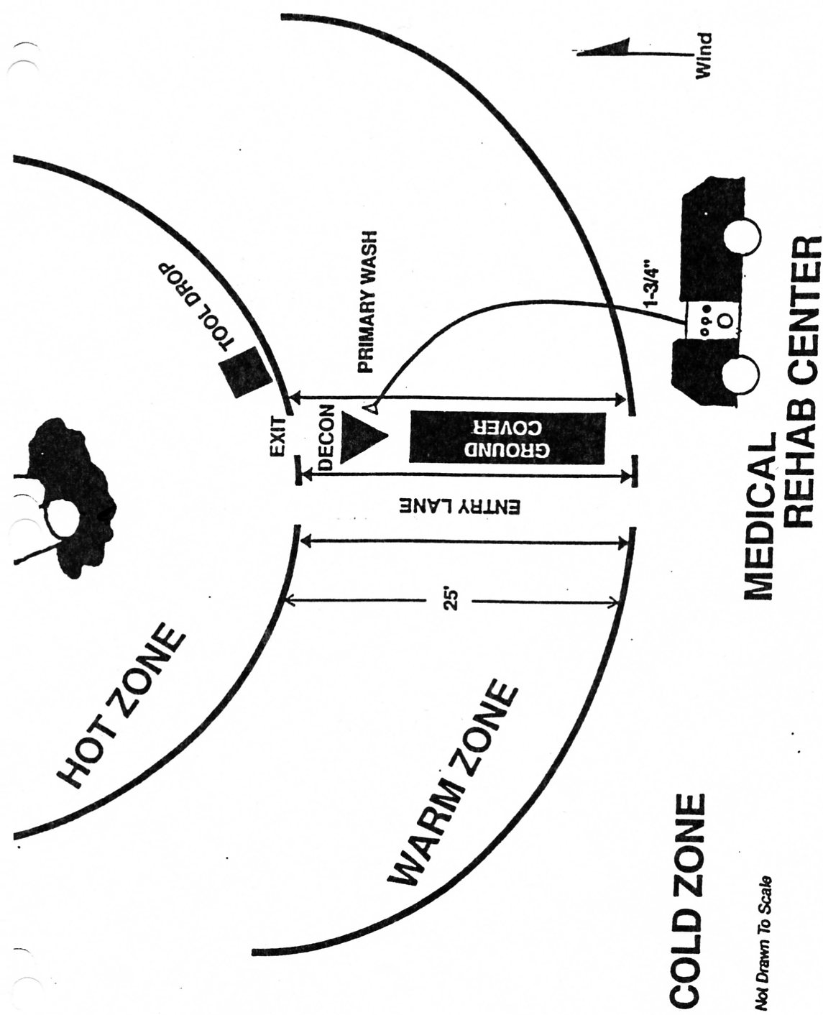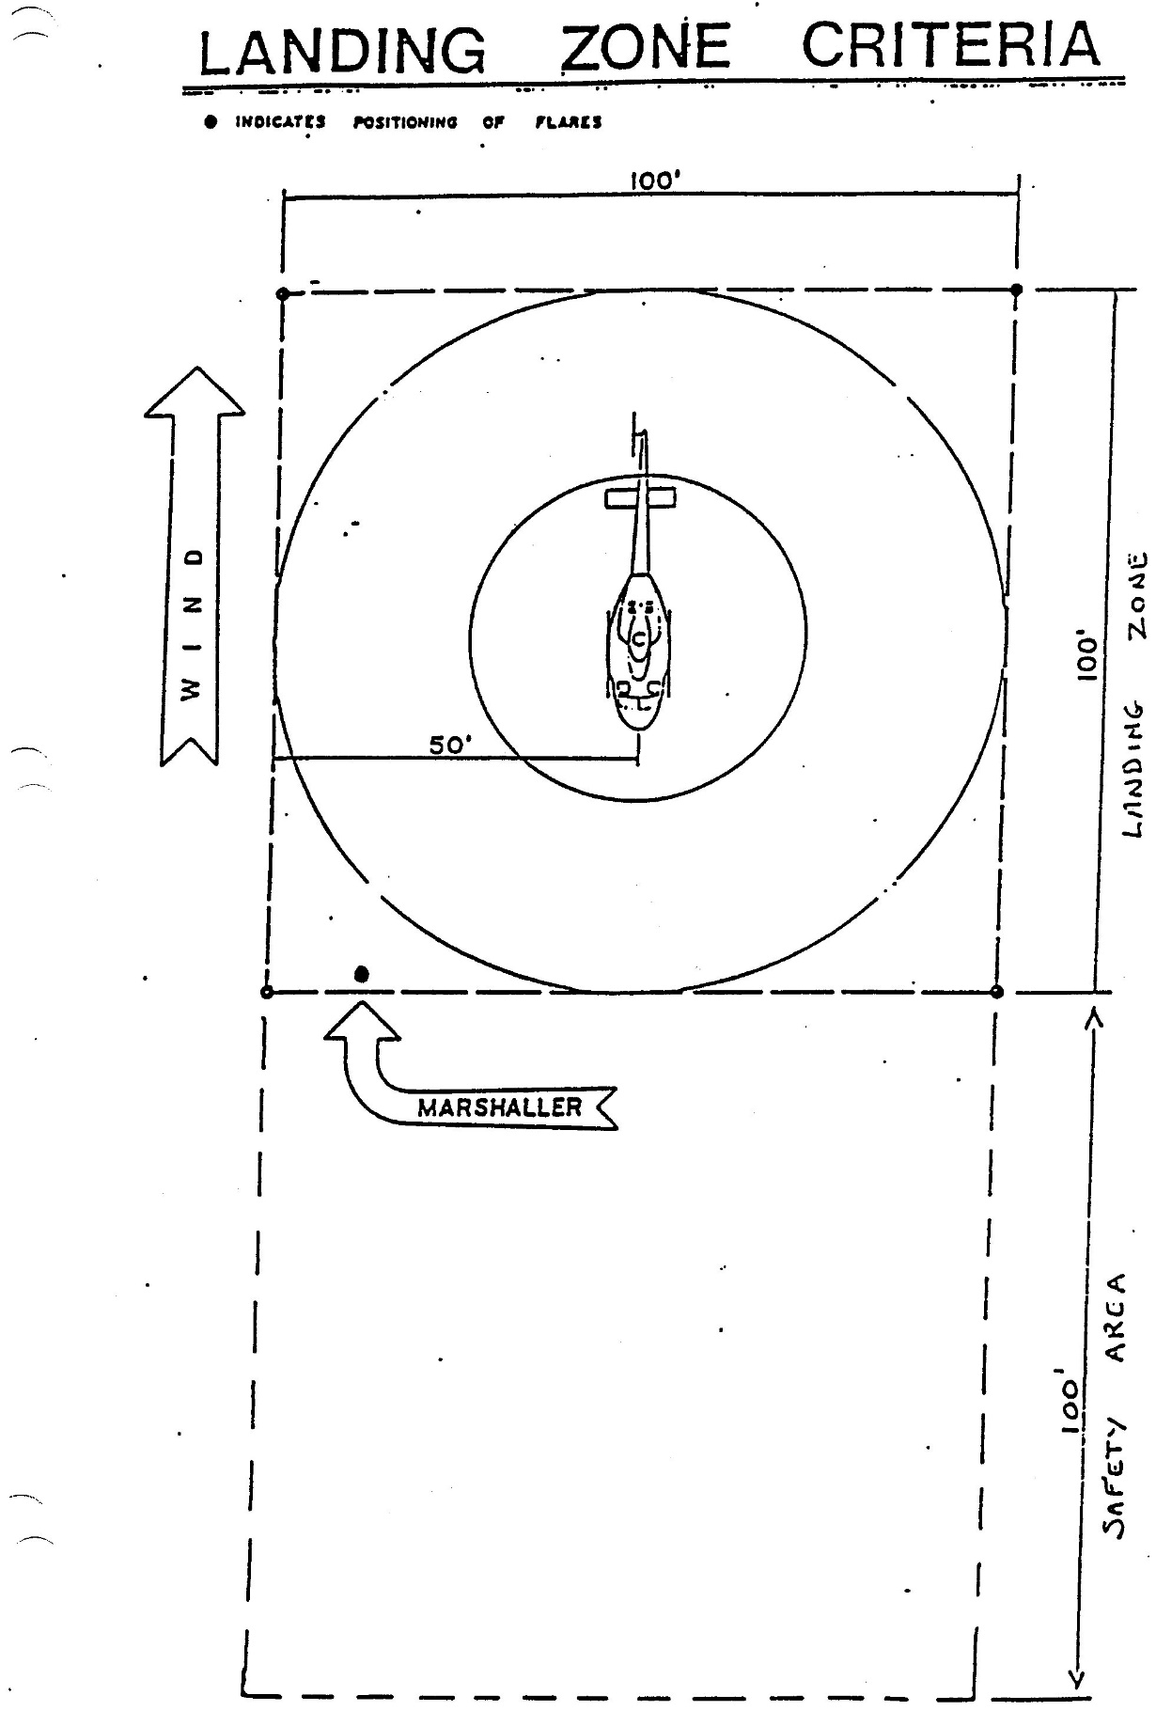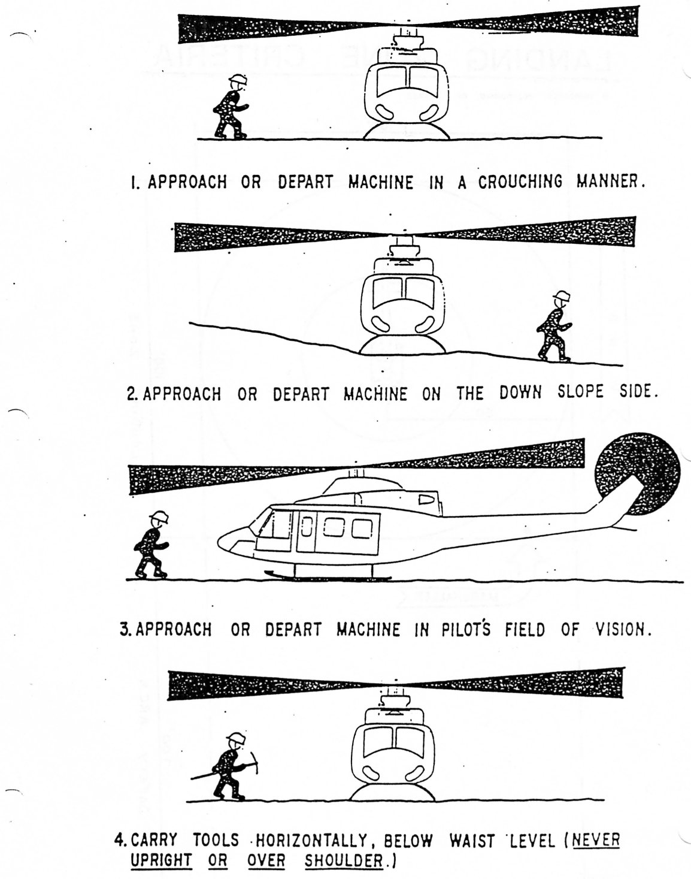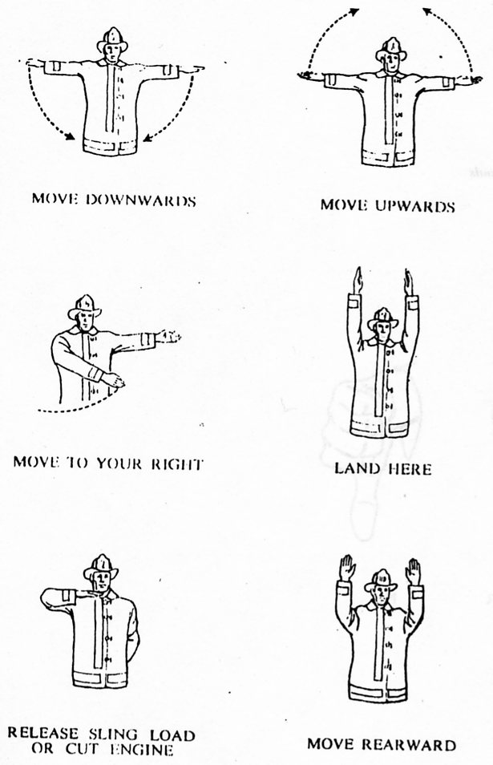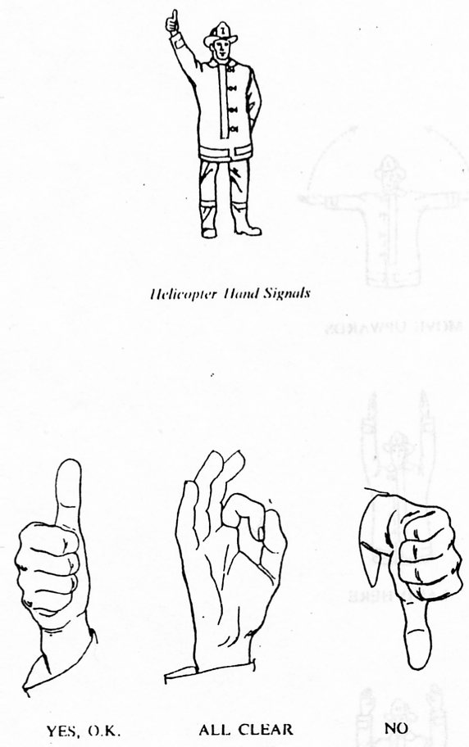
(Your Local Non-Transport Form Here)
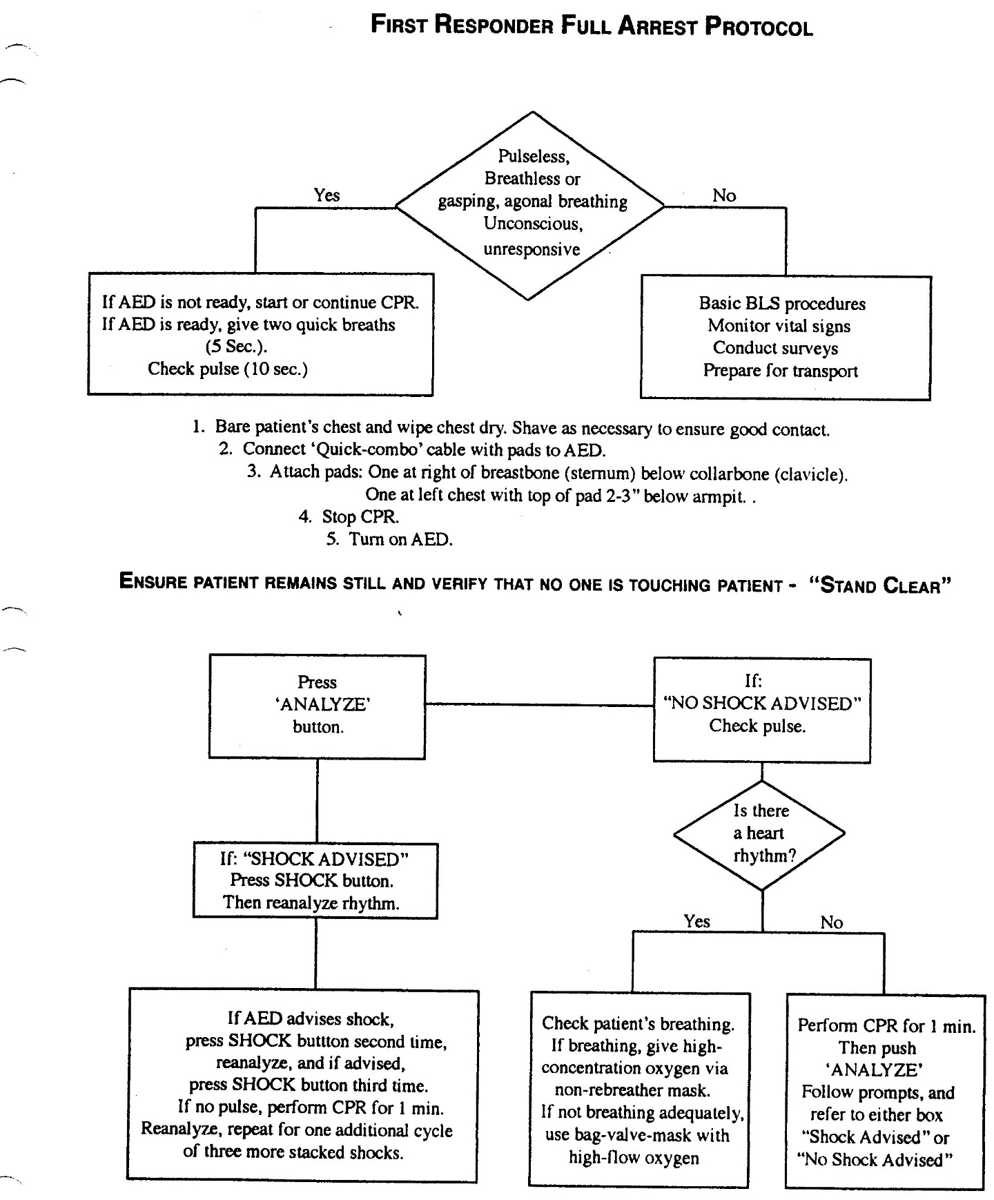
(Your Local EMS Run Sheet Here)
