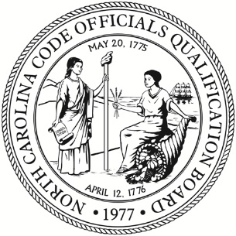

**North Carolina Code Officials Qualification Board**

**Staffed by the NC Office of State Fire Marshal**

**Brian Taylor,** State Fire Marshal 1202 Mail Service Center

**Rob Roegner,** Chief DeputyBoard Secretary Raleigh, NC 27699-1202

**Joseph Starling,** Director

(919) 647-0000 1429 Rock Quarry Road

Raleigh, NC 27610

**Board Members**

**Chairman:**

Bill Thunberg

(At-Large Member)

**Vice Chairman:**

Fleming El-Amin

(Elected Official, County)

**Members:**

Jeffrey Tracey

(Fire Inspector)

Daniel C. Couch

(Elected Official, County)

Les Everett

(CEO, City)

Russell Fox

(Elected Official, City)

Michael Slate

(CEO, County)

Montrena Hadley

(Elected Official, City)

Allen Kelly

(Lic. Mech/Plumbing Cont.)

Adam Lovelady

(UNC School of Government)

Andy Matthews

(Lic. General Contractor)

Mark Patterson

(Architect)

Ahmed Megri, PhD

(NCAT Engineering Faculty)

Mark Smith

(Lic. General Contractor)

James Steele

(Lic. Electrical Contractor)

Mack Summey, PE

(Registered Engineer)

Sajjad Bigham, PhD

(NCSU Engineering Faculty)

Kenny Weatherington

(Community Colleges)

Richard White

(Manager, City)

**Special Meeting**

**August 19, 2025 – 9:00 AM**

NC Office of State Fire Marshal

1429 Rock Quarry Road, Suite 104

Raleigh, NC 27610

Meeting will be held via WebEx.

Join from the meeting link.

<https://ncgov.webex.com/ncgov/j.php?MTID=me90cdc9156c37fd065031fc7180cae2a>

Join by meeting number.

Meeting number (access code): 2429 848 5023

Meeting password: 3urGBDneE28

Tap to join from a mobile device (attendees only)

+1-415-655-0003, 24298485023## US Toll

NOTICE / AGENDA

1. Special Board Meeting

A. Roll Call / Conflict of Interest Reminder

2. Rules Updates

3. Public Comment

4. Adjournment