**DRAFT Minutes of the North Carolina Home Inspector Licensure Board**

**July 12, 2024**

The regular meeting of the North Carolina Home Inspector Licensure Board (“Board”) was held 9:00 AM on Friday, July 12, 2024, in person at 1429 Rock Quarry Rd. Suite 105, Raleigh, NC 27699 and by video teleconference via Webex.

The following members of the Board were present at location:

David Dye D. Arthur Hall Robert Roegner Derrick Johnson

Connie Corey

David Price and Chad Abbott attended via Webex.

William “Bill” Morris was absent.

Gina M. Von Oehsen Cleary from the North Carolina Department of Justice, Attorney General’s Office was present at location as counsel for the Board.

Kyle Heuser Assistant General Counsel from North Carolina Office of the State Fire Marshal was present at location.

The following staff members from the North Carolina Office of the State Fire Marshal, Engineering Division were present at location:

Mike Hejduk Beth Williams Sam Whittington Jeff Griffin

Bonnie Bentley Rodney Daughtry Anna Basile Sarah Barcenas

The following staff members from the North Carolina Office of the State Fire Marshal, Engineering Division were present via Webex:

Rich Hall Katherine Vincent

The following members of the public were present via Webex:

Annie Dance A. Clark Eric Coates

Bonnie Gregory Preston Sandlin Preston Sandlin (2)

J. Hanes Ken Spears Ken Spears (2)

April Gregory April Gergory Shandy Padgett

Matt Lail Matt Lail (2)

Wilson

**Introduction**

Chair David Dye called the meeting to order and provided opening remarks.

Connie Corey read the Ethics Awareness and Conflict of Interest reminder.

**Approval of Minutes**

April 12, 2024, Regular Meeting Minutes

Rob Roegner motioned to approve the April 12, 2024, regular meeting minutes. Connie Corey seconded the motion. Motion carried.

Chair Dye stated he wants the minutes of today’s meeting to show that his son will receive his white coat at graduation today July 12, 2024.

**Staff Report**

Mike Hejduk shared activity statistics for FY 2023-2024 fourth quarter and the end of the fiscal year on the table below. Hejduk stated that licenses and applications are following the industry trend.

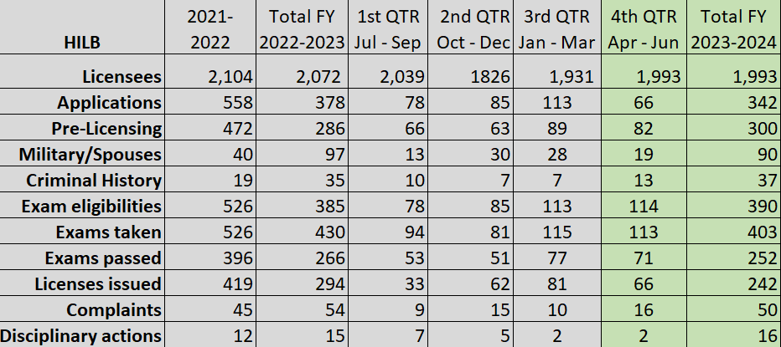

Sam Whittington introduced Investigator, Bonnie Bently.

**Committee Reports**

**Application Evaluation Committee**

Connie Corey reported the Application Evaluation Committee met on July 26, 2024, via Webex and reviewed the following 11 applications.

1. Joseph Herring

2. Mitchell Dukes

3. Frankie Flecher

4. Randy Thurston

5. Clint Bailey

6. Narita Norman

7. Franklin McClure

8. John Anderson

9. Blane Garfield

10. David Heishman

11. Matthew Brodeur

Roegner made a motion to approve the following three (3) out-of-state home inspector applicants to sit for the licensure exam. Arthur Hall seconded the motion. Motion carried.

1. Joseph Herring

2. Mitchell Dukes

3. Frankie Flecher

Roegner made a motion to approve the following general contractor qualifier applicant to sit for the licensure exam. Derrick Johnson seconded the motion. Motion carried.

1. Randy Thurston

Roegner made a motion to approve the following applicant to sit for the licensure exam. Johnson seconded the motion. Motion carried.

1. Clint Bailey

Chair Dye stated that there are no guidelines for criminal background checks for the Committee and Board members to follow when reviewing the applications that contain criminal history reports. Gina M. Von Oehsen Cleary stated that the Board does have guidelines and they are listed on the Board’s website. Corey stated that the Application Evaluation Committee members are to receive the guidelines from staff before every meeting for review.

Roegner made a motion to approve the following applicant to sit for the licensure exam. Hall seconded the motion. Motion carried.

1. Narita Norman

Hall made a motion to approve the following applicant to sit for the licensure exam. Roegner seconded the motion. Motion carried.

1. Franklin McClure

Roegner made a motion to approve the following applicant to sit for the licensure exam. Johnson seconded the motion. Motion carried.

1. John Anderson

Roegner made a motion to approve the following applicant for pre-determination on completing the pre-licensing courses and sitting for the licensure exam upon completion. Hall seconded the motion. Motion carried.

1. Blane Garfield

Roegner made a motion to approve the following applicant for pre-determination on completing the pre-licensing courses and sitting for the licensure exam upon completion Johnson seconded the motion. Motion carried.

1. David Heishman

Roegner made a motion to approve the following applicant who appealed a prior denial from the Board to sit for the licensure exam. Johnson seconded the motion. Motion carried.

1. Matthew Brodeur

**Examination Committee**

Roegner reported the Examination Committee met on July 8, 2024, via Webex.

Roegner shared the following items discussed.

* eBook: Home Inspector Handbook
* Exam Reviews
* Testing Software and Remote Proctoring

Rich Hall shared information about the Home Inspector eBook, exam reviews, and testing software.

Roegner motioned to discontinue exam reviews as of October 1, 2024, and by that date staff will have a menu available that will be given to the test taker of how they performed by category on the exam. Hall seconded the motion. Motion carried.

Roegner motioned N.C. Home Inspector Licensure Board shoulder their portion of the cost to hire an online testing vendor. Anticipated cost is $10,000.00 earmarked. Hall seconded the motion. Motion carried.

**Finance Committee**

Hejduk shared the tables below stating that the first table shows revenue coming in for the fiscal year and the second table shows the fund balance.

Revenue Collected:

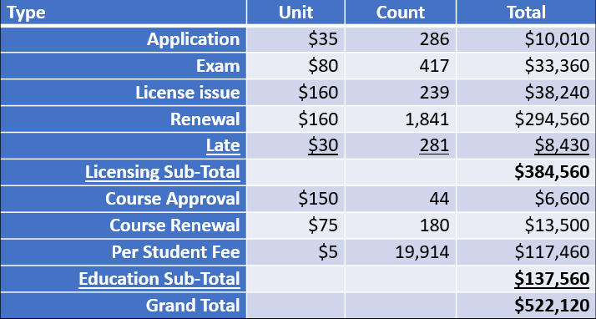

Expenditures:

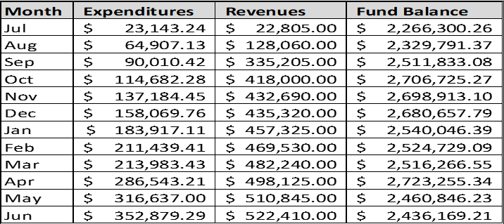

**Legislative Committee**

Hejduk stated that new rule changes will go into effect October 1, 2024. On October 1, 2024 the rule changes will be posted to the Board website. Rob Roegner discussed H850.

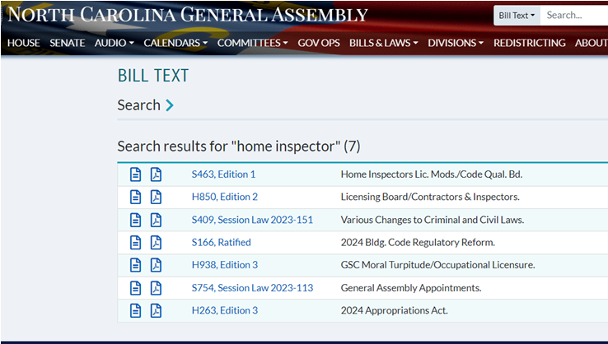

**Education Committee**

Johnson reported the Committee met on June 27, 2024, via Webex and shared the bullet points below.

* Bonnie Gregory gave update on FY 2024-2025 Board-developed Update course timeline.
* Pre-drywall will be part of current license and standard taught through CE. We will need the SOP committee give rules and procedures for Dry-wall inspections.
* Rich Hall gave update on E-book**.**
* Pre-licensing 120-hour
* Anita Davidson – Approved

Roegner motioned to approve Anita Davidson to be an education sponsor. Johnson seconded the motion. Motion carried.

**Standards of Practice Committee**

Committee met on July 2, 2024. Chair Dye reported the following items discussed at the Committee meeting.

* Proposed Rule changes updates.
* Pre-drywall Inspections
* Public Comment

Board and staff discussed pre-drywall inspections. Sam Whittington will lead a committee for exploratory pre-drywall inspections with the help of Derrick Johnson, Chair Dye, Connie Corey, and Rich Hall.

Board discussed “walk and talks” in response to comments by Preston Sandlin.

**Investigation Review Committee**

Arthur Hall reported the Committee met on July 4, 2024, and July 8, 2024, and reviewed the following cases.

**Consent Agreement**

* **782** Tatum #1233 (Pointer)
* **985** Tatum #1233 (Pennie)
* **987** Durham #4653 (McKenny)
* **1012** Woodie #4171 (Graff)
* **1016** McAlexander #3594 (Mauldin)
* **1018** Pace #4983 (Altero)
* **1029** Rogers #5297 (Verla)

Roegner made a motion to approve a consent agreement for **782** Tatum and **985** Tatum. Corey seconded the motion. Motion carried.

Roegner made a motion to approve a consent agreement for **987** Durham. Corey seconded the motion. Motion carried.

Roegner made a motion to approve a consent agreement for **1012** Woodie. Corey seconded the motion. Motion carried.

Roegner made a motion to approve a consent agreement for **1016** McAlexander. Corey seconded the motion. Motion carried.

Roegner made a motion to approve a consent agreement for **1018** Pace. Corey seconded the motion. Motion carried.

Roegner made a motion to approve a consent agreement for **1029** Rogers. Corey seconded the motion. Motion carried.

The Board took a 10 minute break/recess from 10:50 to 11:00 AM then resumed the Investigation Review Committee report.

**Letter of Caution**

* **1015** Saunders #4727 (Lynch)

Roegner made a motion for Letter of Caution for **1015** Saunders. Corey seconded the motion. Motion carried.

**Dismiss**

* **1011** Robertson #1729 (Harper)
* **1021** Mensah #4618 (Daniels)
* **1022** Lanzetta #4386 (Lloyd)
* **1023** Silver #5724 (Davis)
* **1025** Pittman #3056 (Sekela)
* **1027** Zhang #3542 (Colhoun)
* **1028** Rhue #5185 (Hazel)
* **1030** Fausel #2664 (Nanwani)
* **1031** Durham #4653 (McKenny)
* **1033** Hardin #4076 (King)

Roegner made a motion to block and dismiss cases **1011** Robertson, **1021** Mensah, **1022** Lanzetta, **1023** Silver, **1025** Pittman, **1027** Zhang, **1028** Rhue, **1030** Fausel, **1031** Durham, and **1033** Hardin. Corey seconded the motion. Motion carried.

**Other Recommendations to the Board**

* Walk and Talk inspections, recommended the Board send potential license law violation letters to three home inspection companies Assurance, Parkwood, and Stratton.

Roegner made a motion to send potential license law violation letters to Assurance, Parkwood, and Stratton. Corey seconded the motion. The motion carried.

Hejduk stated that the Board does not license companies so approximately 20 individual licensees of the companies will receive potential license law violation letters.

**Public Comment**

Bonnie Gregory commented on the company HomeCloud soliciting “walk and talks”.

Chair Dye stated there is progress being made in the case of HomeCloud.

Annie Dance asked if the eBook will be made into a PDF. Chair Dye stated the eBook will not be a downloadable PDF.

**Unfinished Business**

Hejduk reviewed the following.

* Approved Rule Changes
* HomeCloud Update
* Strategic Planning Session
* Report Reviews

Hejduk recommended to budget for a mailing of the updated SOP (Standards of Practice) to all licensees.

Roegner made a motion to approve the new rules as approved by the Office of Administrative HearingsRules Review Commission and put on the website for the Home Inspection Licensure Board. Corey seconded the motion. Motion carried.

Cleary stated that the Attorney General’s Office sent an advisory request letter to HomeCloud on July 11, 2024. Cleary stated a motion is needed to reserve the attorney client privilege to go into closed session authorized by N.C. Gen. Stat. §143-318.11 (3) to consult with the attorney (Cleary) employed by the Board.

Chair Dye tabled making a motion on HomeCloud until all points on agenda are completed.

Rodney Daughtry shared an update on the planning session scheduled for the October Board meeting. The new accounting forms for Board member reimbursements were given to Board members and sent electronically to Board members not present at location.

Chair Dye, Board members, and staff discussed topics to be addressed at the Board planning session in October 2024.

Chair Dye tabled the discussion of report reviews for home inspectors to the October 2024, Board planning session.

**New Business**

Roegner and Hejduk posed the question if the Board wanted to retain the Facebook page and if other social media needs to be maintained.

Chair Dye, Board members, and staff tabled the discussion to the October 2024, Board planning session.

**Election of Officers**

Corey recommended that the position of Chair and Vice Chair be a two (2) year term instead of the one (1) year term.

Cleary stated the bylaws need to be reviewed when deciding to change from a one (1) year to a two (2) year term.

Corey made a motion to approve the following slate of Board officers:

* Chair, David Dye
* Vice Chair, William “Bill” Morris
* Treasurer, David Price
* Secretary, Rob Roegner

Chair Dye recommended David Price be appointed to Vice Chair and Treasurer be appointed to William “Bill” Morris. Hall seconded the motion. Motion carried.

Corey made a motion to go into executive closed session at 11:38 AM pursuant N.C. Gen. Stat. § 143-318.11 (3). Hall seconded the motion. Motion carried. The Board emerged from closed session 12:37 PM and returned to open session.

**Adjournment**

Motion to adjourn by acclamation.

Sincerely,

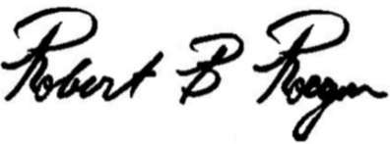

Secretary, N.C. Home Inspector Licensure Board